Test Name: 2019-2020 Math 8 Semester 1 Exam REVIEW

1 | 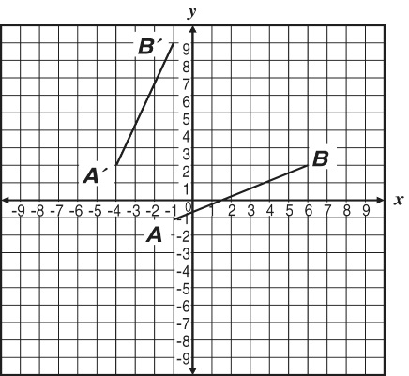  Segment $\overset{____}{A^{'}B^{'}}$ is a transformation of segment $\overset{____}{AB}$ .
 | A | $\overset{____}{A^{'}B^{'}}$ is a translation of $\overset{____}{AB}$ left 3 units. | C | $\overset{____}{A^{'}B^{'}}$ is a reflection of $\overset{____}{AB}$ over the line $y=x+3$ .
 | B | $\overset{____}{A^{'}B^{'}}$ is a 90-degree rotation of $\overset{____}{AB}$ . | D | $\overset{____}{A^{'}B^{'}}$ is a translation of $\overset{____}{AB}$ up 3 units.

2 | Rectangle PQRS has side lengths of 7 and 3 as shown on the grid below.  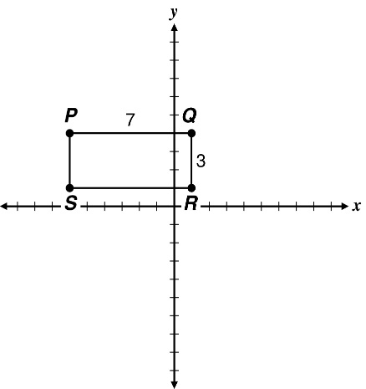  Rectangle PQRS is reflected across the y-axis to form Rectangle $P^{'}Q^{'}R^{'}S^{'}$ What is the length of $Q^{'}R^{'}$
 | A | 3 | C | 7
 | B | 6 | D | 14

3 | 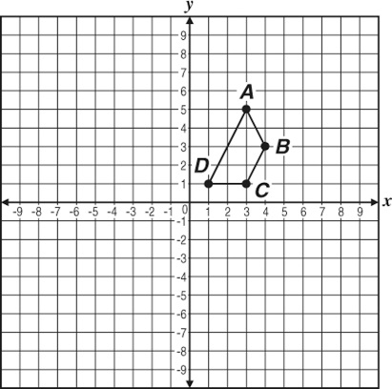  Reflect Quadrilateral ABCD over the y-axis and then translate it six units down.  What are the coordinates of the final image of Point B?
 | A | (–10, 3) | C | (–3, –1)
 | B | (–4, –3) | D | (4, –9)

4 | A geometric transformation is described algebraically as shown below.  $(x,y)→(3x,3y)$  Which best describes this transformation?
 | A | a translation 3 units up and 3 units to the right | C | a 180° degree rotation centered at the point $(3,3)$
 | B | a translation 3 units down and 3 units to the left | D | a dilation with scale factor 3 centered at the origin

5 | Esteban drew Triangle JKL on a coordinate plane, with J(–3, 5), K(–1, –4), and L(2, 4). Then he drew Triangle J'K'L', the result of the dilation ($x,y$) $→(\frac{2}{3}x,\frac{2}{3}y)$. What are the coordinates of Point J'?
 | A | $$(-2,5)$$ | C | $$(-2\frac{1}{3},5\frac{2}{3})$$
 | B | $$(-2,3\frac{1}{3})$$ | D | $$(-3,3\frac{1}{3})$$

6 | Which graph shows a rectangle similar to the rectangle below?  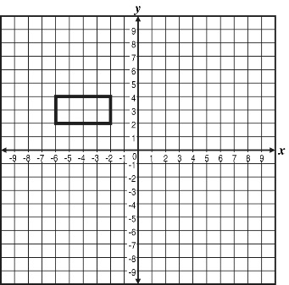
 | A | 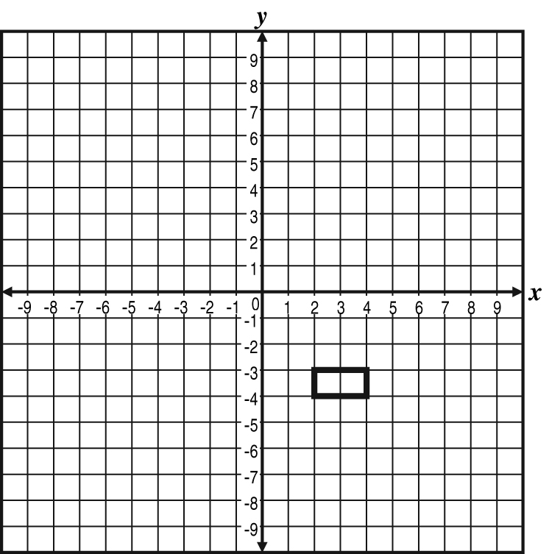 | C | 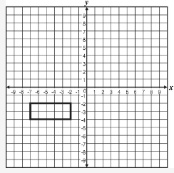
 | B | 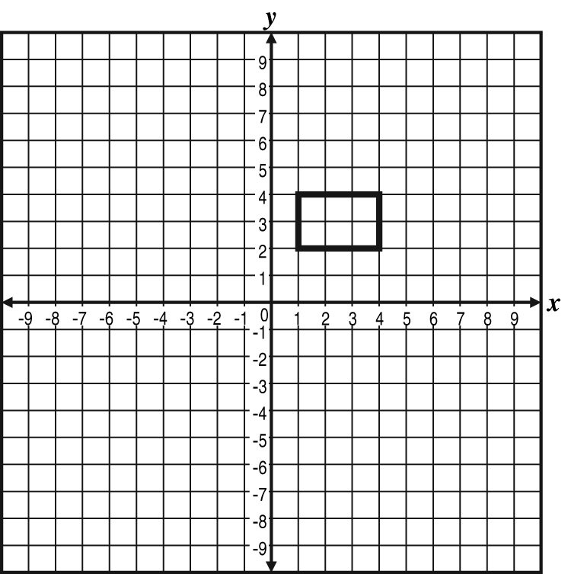 | D | 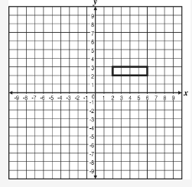

7 | A piece of artwork has similar rectangles that are translated. Which one of these best represents this artwork?
 | A |  | C
 | B |  | D

8 | 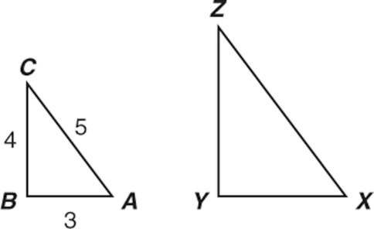  $△ABC△XYZ$ are similar.  What could be the lengths of the sides of$△XYZ$
 | A | $$XY=6 YZ=8 XZ=9$$ | C | $$XY=10 YZ=8 XZ=15$$
 | B | $$XY=7 YZ=8 XZ=9$$ | D | $$XY=12 YZ=16 XZ=20$$

9 | The rectangular dining room floor at Mrs. Washington’s restaurant is 16 feet by 20 feet. She wants to buy a rug that is geometrically similar to the dining room floor. Which rug dimensions correspond to a rug that would be similar to the floor?
 | A | 8 feet by 12 feet | C | 12 feet by 15 feet
 | B | 10 feet by 14 feet | D | 14 feet by 18 feet

10 | Parallel lines g and h are shown on one grid, and parallel lines k and j are shown on the other grid.  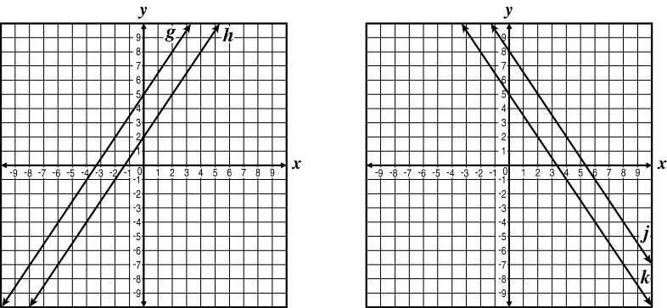  Which statement is true in terms of the transformation from lines g and h to create lines j and k?
 | A | Lines g and h were translated to the right 8 units. | C | Lines g and h were reflected over the y-axis and then reflected over the x-axis.
 | B | Lines g and h were reflected over the y-axis and then translated up 3 units. | D | Lines g and h were reflected over the x-axis and then translated to the right 5 units.

11 | 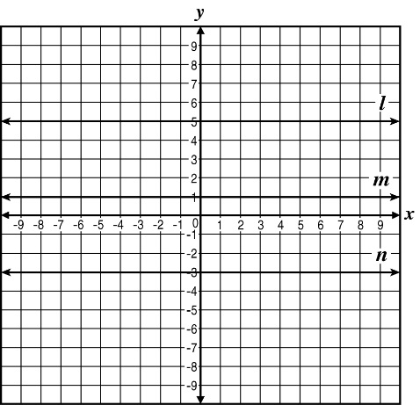  Parallel lines l, m, and n are shown.  If line l is mapped to line m and line m is mapped to line n, what is true for the transformation that took place?
 | A | Line n was translated up 8 units. | C | Line l was translated down 8 units.
 | B | Line m was translated up 4 units | D | Line m was translated down 4 units.

12 | 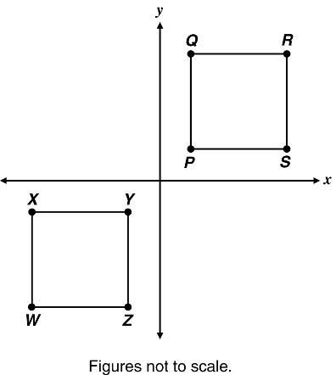  Quadrilateral PQRS is rotated 180° about the origin.  Which angle in Quadrilateral WXYZ must necessarily measure the same as Angle Q?
 | A | Angle W | C | Angle Y
 | B | Angle X | D | Angle Z

13 | 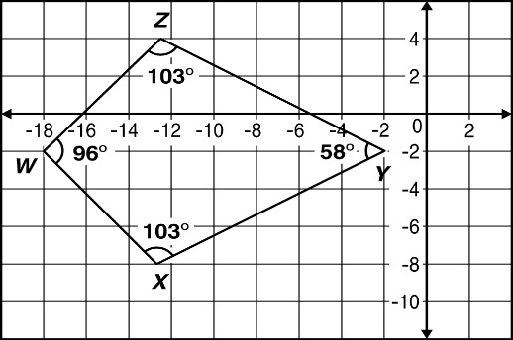  Figure WXYZ is shown below.  Figure WXYZ is translated up 3 units and 4 units to the right to create Figure W'X'Y'Z'. What is the measure of angle Z' after this transformation?
 | A | 103° | C | 77°
 | B | 96° | D | 58°

14 | 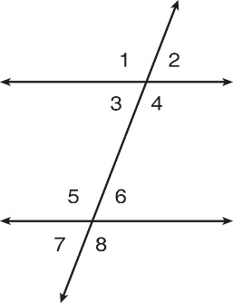  In the following diagram, two parallel lines are cut by a transversal.  The measure of which angle is equal to the measure of$∠1$
 | A | $$m∠2$$ | C | $$m∠4$$
 | B | $$m∠3$$ | D | $$m∠6$$

15 | Maple Street and Elm Street are parallel to each other and both intersect Arbor Street.  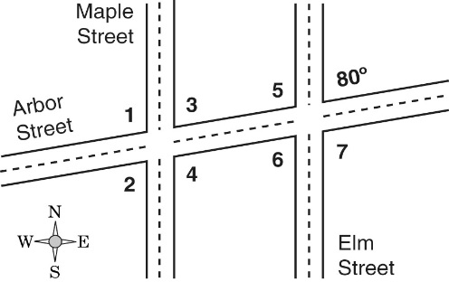  Which statement must be true?
 | A | $$m∠1=80$$ | C | $$m∠2=80$$
 | B | $$m∠3=m∠7$$ | D | $$m∠7=m∠6$$

16 | In the figure below, $\overset{____}{KG}$ and $\overset{____}{JH}$ are parallel to $\overset{____}{DF}$ of $∆DEF.$  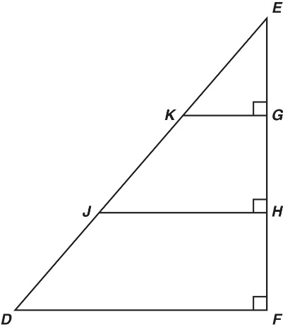  Which pair of angles is congruent?
 | A | $∠DEF$ and$∠EDF$ | C | $∠GKJ$ and$∠KJH$
 | B | $∠KEG$ and$∠EKG$ | D | $∠EJH$ and$∠JDF$

17 | 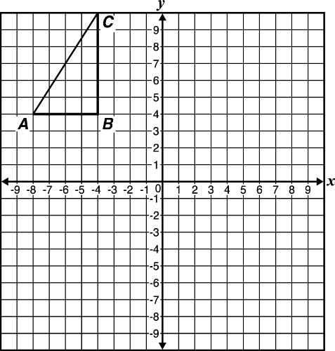  A triangle having vertices at $A(-8,4)$ , $B(-4,4)$, and $C(-4,10)$ is dilated by a scale factor of $\frac{1}{2}$ to form Triangle A'B'C'.  Which statement is true?
 | A | The length of A'C' is one-half the length of AC. | C | The length of A'C' is twice the length of AC.
 | B | The length of A'C' is the same as the length of AC. | D | The length of A'C' is four times the length of AC.

18 | Given that these two right triangles are similar, what is the value of x?  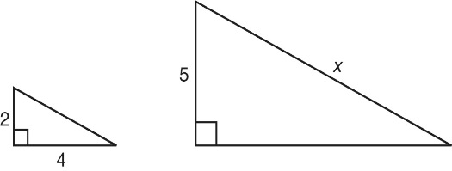
 | A | $$3\sqrt{5}$$ | C | 10
 | B | 7 | D | $$5\sqrt{5}$$

19 | 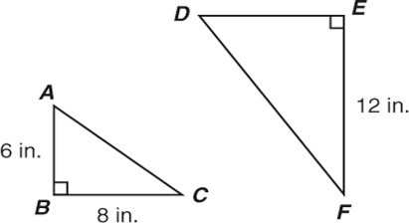  In the figure below, $△ABC$ is similar to $△DEF$. What is the length of $\overline{DE}$?
 | A | 8 in | C | 10 in
 | B | 9 in | D | 16 in

20 | A church has an isosceles triangular window. The lengths of the sides of this window are 2.5 feet, 2.5 feet, and 3.5 feet. A nearby church has a similar window. Which best represents the length of sides of the second window?
 | A | 1.25 feet, 1.25 feet, 1.25 feet | C | 5 feet, 5 feet, 4 feet
 | B | 1.25 feet, 1.25 feet, 2.75 feet | D | 3.75 feet, 3.75 feet, 5.25 feet

21 | 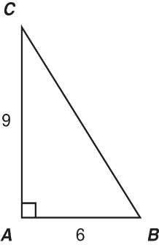  Which is a dilation of $△ABC$ with a scale factor of $\frac{2}{3}$
 | A | 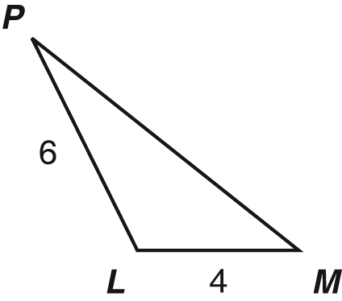 | C | 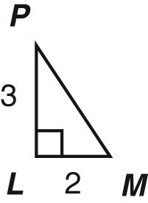
 | B | 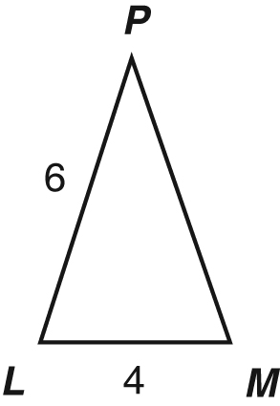 | D | 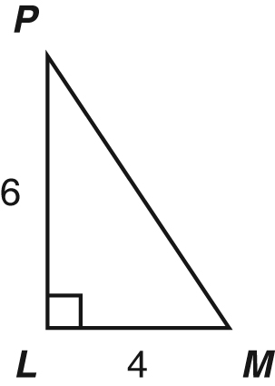

22 | 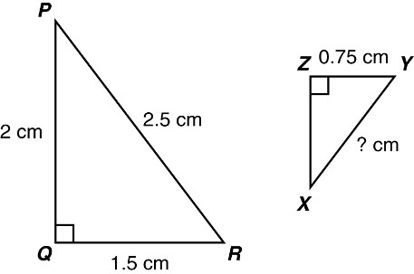  Triangle PRQ is similar to Triangle XYZ as shown below. The dimensions are given in  centimeters (cm).  What is the length, in centimeters, of$\overset{____}{XY}$
 | A | 0.45 | C | 1.25
 | B | 1 | D | 5

23 | Which of the following equations has no solution?
 | A | $$7x-3x-4=4$$ | C | $$3(2x-4)=6(x-2)$$
 | B | $$7x-3x+4=4$$ | D | $$3(2x-4)=6(x+2)$$

24 | Which equation has no solution?
 | A | $$3k-20=12$$ | C | $$12x+6=3(4x+2)$$
 | B | $$8+15g=15+8g$$ | D | $$9p+7=6p-2+3p$$

25 | Which equation has only one solution?
 | A | $$6r=5r+r$$ | C | $$8v+11=8v+11$$
 | B | $$4m+5=25$$ | D | $$2-3p=-3p+5$$

26 | Which statement regarding the number of solutions for the linear equation shown below is true?  $$\frac{1}{4}x-13=\frac{1}{4}(x+13)$$
 | A | There is no solution. | C | There are exactly two solutions.
 | B | There is exactly one solution. | D | There are infinitely many solutions.

27 | A linear equation is shown below.  $$10w+19+3w=6(9+w)-14$$  Which statement is true?
 | A | The equation has no solution. | C | The solutions to the equation are 3 and 7.
 | B | The solution to the equation is 3. | D | The equation has infinitely many solutions.

28 | If $-3x=57$ what is the value of x?
 | A | –171 | C | 54
 | B | –19 | D | 60

29 | If the equation $5(3x+7)-1=3(5x+k)+4$ has infinitely many solutions, what is the value of k?
 | A | 7 | C | 27
 | B | 10 | D | 30

30 | What value of x makes the equation $-4+\frac{1}{2}x=8$ true?
 | A | 6 | C | 12
 | B | 8 | D | 24

31 | What value of x makes the equation $3x+6=15$ true?
 | A | 3 | C | 7
 | B | 6 | D | 11

32 | One of the tires on the truck Ian is rebuilding has a slow leak. The recommended inflation pressure of the tire is 35 pounds per square inch (psi). Due to the leak, the tire loses approximately 3 psi of pressure each day. The equation below can be used to determine I, the tire’s inflation pressure when d days have passed since it was properly inflated.  $$I=35-3d$$  How many days have passed if the tire’s inflation is approximately 11 psi?
 | A | 3 | C | 15
 | B | 8 | D | 24

33 | Enrique was asked to solve the equation$3(x+2)=12$ His steps are shown.  Step 1: $3(x+2)=12$  Step 2: $3x+6=12$  Step 3: $3x=6$  Step 4: $x=3$  Which statement about his solution is correct?
 | A | The problem is worked correctly at each step. | C | In Step 3 the problem should be $3x=18.$
 | B | In Step 2 the problem should be $3x+2=12.$ | D | In Step 4 the problem should be $x=2.$

34 | Which equation is equivalent to 3(2m + 7) = −5(6 + m)?
 | A | $$6m+7=-30+m$$ | C | $$6m+21=-30+5m$$
 | B | $$6m+7=-30-m$$ | D | $$6m+21=-30-5m$$

35 | If $10p=-720$ what is the value of p?
 | A | 7200 | C | –72
 | B | 72 | D | –7200

36 | Two hoses are used to fill a swimming pool. Together they fill the pool at a rate of 3 gallons every 5 seconds. An equation representing this is$g=\frac{3}{5}t$ where t is the time in seconds and g is the number of gallons. About how many hours will it take to fill the pool if it holds 80,000 gallons?
 | A | 4 | C | 13
 | B | 7 | D | 37

37 | 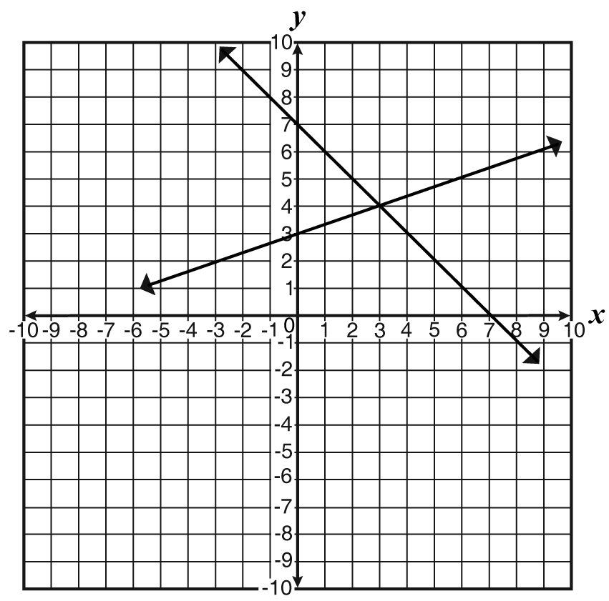  A pair of linear equations is graphed below.  $$\{\begin{matrix}y=-x+7 \\ y=\frac{1}{3}x+3⁢\end{matrix}$$  Which values for x and y would satisfy both of these equations?
 | A | x = 0, y = 3 | C | x = 4, y = 3
 | B | x = 3, y = 4 | D | x = 3, y = 7

38 | 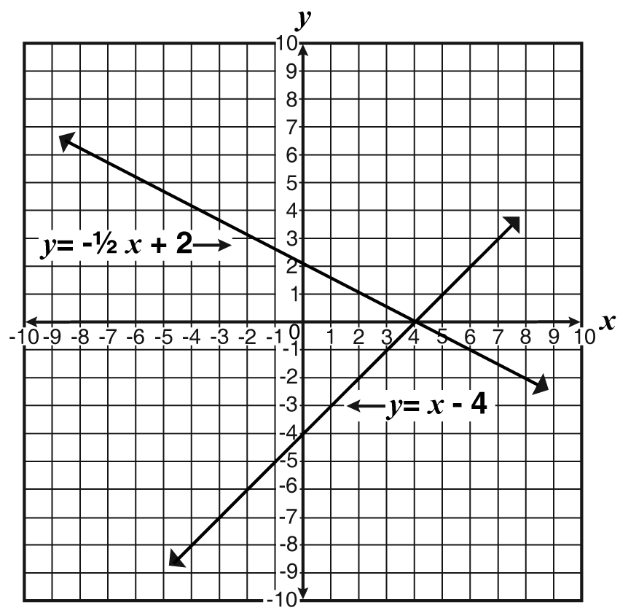  A system of linear equations is graphed below.  Which coordinate point represents the solution?
 | A | (0, 4) | C | (0, – 4)
 | B | (4, 0) | D | (4, – 4)

39 | Terry sold 30 cans of paint at a total cost of $425. A can of paint holding one quart cost $10 each. A can of paint holding one gallon cost $15 each. The equations and graph below can be used to determine the number of cans of paint Terry sold, where x represents the number of quarts of paint, and y represents the number of gallons of paint.  Number of cans: $x+y=30$  Total cost of cans: $10x+15y=425$  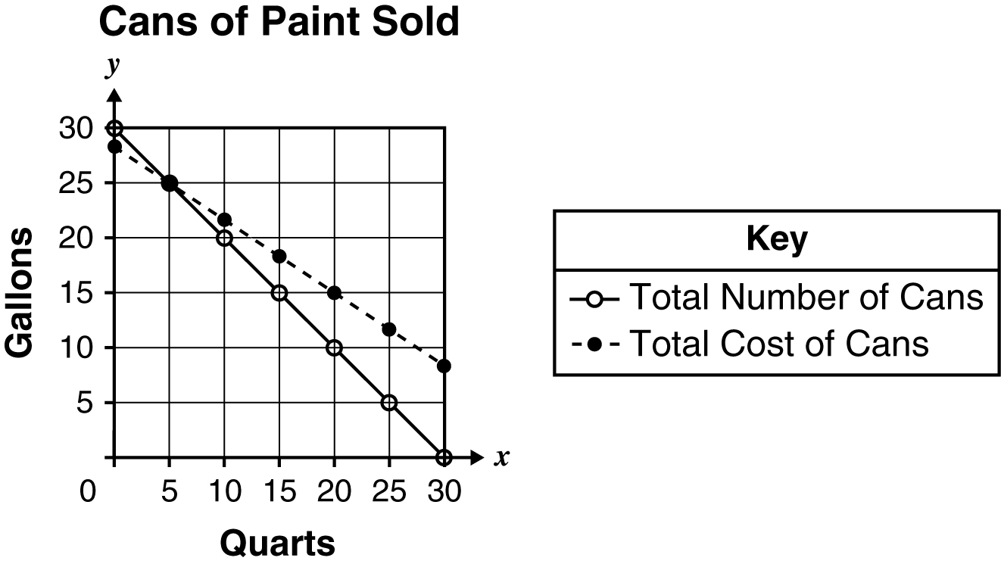  How many quart and gallon cans of paint did Terry sell?
 | A | 5 quarts, 25 gallons | C | 25 quarts, 5 gallons
 | B | 15 quarts, 15 gallons | D | 42 quarts, 28 gallons

40 | 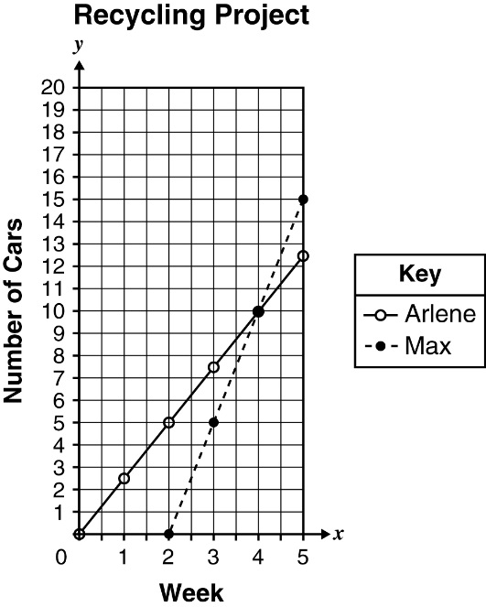  For a recycling project Max and Arlene collected aluminum cans over 5 weeks. The graph below shows the total number of cans each collected over the 5-week project.  In which week did Max and Arlene have the same number of cans?
 | A | Week 2 | C | Week 10
 | B | Week 4 | D | Week 14

41 | What ordered pair represents the solution to this system of linear equations?  $$3y=2x+2$$  $$y=\frac{4}{3}x+1$$
 | A | $$(-\frac{1}{2},\frac{1}{3})$$ | C | $$(\frac{1}{3},-\frac{1}{2})$$
 | B | $$(-\frac{1}{3},\frac{1}{2})$$ | D | $$(\frac{1}{2},-\frac{1}{3})$$

42 | What is the y-coordinate of the ordered pair that satisfies this system of linear equations?  $$\begin{matrix}6x+4y=-14 \\ -x-5y=11\end{matrix}$$
 | A | 2 | C | –1
 | B | 1 | D | –2

43 | An apartment building contains 100 units. The one-bedroom units rent for $495 per month and the two-bedroom units rent for $600 per month. When all the units are rented out, the total monthly rent paid by the tenants is $55,275. How many two-bedroom apartments are there?
 | A | 45 | C | 55
 | B | 50 | D | 66

44 | Sports Warehouse had a sale on two models of baseball gloves. Model A sold for $30.00, and model B sold for $45.25. A total of 52 gloves was sold. The total amount of sales earned on the gloves, excluding tax, was $2,078.50. How many model B baseball gloves were sold?
 | A | 18 | C | 29
 | B | 22 | D | 34

45 | Jeremy plays basketball for the Varsity team. Last season, he scored a total of 1489 points consisting of 2-point and 3-point baskets. If Jeremy made a total of 640 baskets, how many of the baskets counted 3 points?
 | A | 209 | C | 1227
 | B | 431 | D | 1489

46 | The length of a rectangle is 16 inches longer than its width. If the perimeter of the rectangle is 540 inches, what is the length in inches?
 | A | 111 | C | 135
 | B | 127 | D | 143

