JH Algebra Midterm 2019-2020 REVIEW

1. | Which is the simplified form of $10-5x<20$
 | A. | $$x<-5$$ | C. | $$x>-2$$
 | B. | $$x<-2$$ | D. | $$x>-6$$

2. | Gabriela wants to show that the following is true by example.  Given a system of two equations in two variables, replacing one equation by the sum of that equation and a multiple of the other produces a system with the same solutions.  She begins with the system of linear equations below.  $\begin{matrix}6x-2y=-4 \\ 2x+y=-8\end{matrix}$ She then multiplies the second equation by -3. What should she do next?  Then solve the system.
 | A. | Add 6 x – 2 y = – 4 to 2 x + y = – 8.
 | B. | Add -6 x - 3 y = 24 to 6 x – 2 y = – 4.
 | C. | Multiply 2 x + y = – 8 by 2 and add to $6x-2y=-4$.
 | D. | Multiply 6 x – 2 y = – 4 by 3 and add to $6x+3y=-24$.

3. | 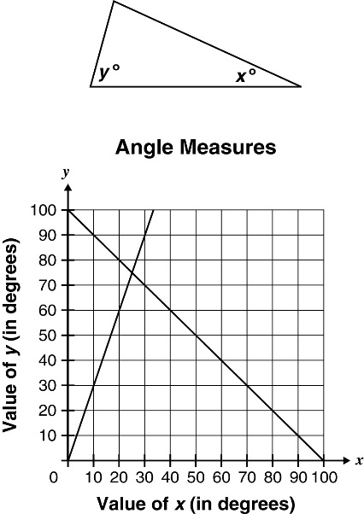  The sum of the values of x and y in the triangle below is 100°. The value of y is 3 times greater than the value of x .  $$\begin{matrix}x+y=100 \\ y=3x\end{matrix}$$  What are the values of x and y ?
 | A. | $$x=20° y=60°$$ | C. | $$x=70° y=30°$$
 | B. | $$x=25° y=75°$$ | D. | $$x=75° y=25°$$

4. | Janine is considering two movie rental plans. Plan A can be modeled with the equation $C=3m$ and Plan B can be modeled with the equation $C=2m+5$ where C represents the cost in dollars and m represents the number of movies rented each month. Which statement would justify selecting Plan B instead of selecting Plan A?
 | A. | Janine rents 5 to 10 movies each month. | C. | Janine rents exactly 3 movies each month.
 | B. | Janine rents exactly 5 movies each month. | D. | Janine rents from 1 to 5 movies each month.

5. | Look at the equation of Line $l$ . $\frac{x}{3}-\frac{y}{7}=3$ Through which point does Line $l$ pass?
 | A. | (−7, 6) | C. | (6, 7)
 | B. | (6, −7) | D. | (7, 6)

6. | The equation $P=2l+2w$i s used to find P , the perimeter of a rectangle, using the length ( l ) and the width (w) of the rectangle. What is an equivalent equation solved for w ?
 | A. | $$w=P-2l$$ | C. | $$w=\frac{P-2l}{2}$$
 | B. | $$w=\frac{P}{2}-2l$$ | D. | $$w=2(P-2l)$$

7. | Which equation is equivalent to 2 x + 3 y = 12?
 | A. | $$y=\frac{2}{3}x+4$$ | C. | $$y=-\frac{2}{3}x+12$$
 | B. | $$y=-\frac{2}{3}x+4$$ | D. | $$y=\frac{2}{3}x+12$$

8. | Which number is not an element in the range of the equation $y=2x^{2}-6$ for the domain of $\{-3,5,6\}$
 | A. | 12 | C. | 44
 | B. | 30 | D. | 66

9. | Which number is a value in the range of the equation $y=x^{2}+7$ for the domain of $\{-2,5,6\}$
 | A. | 3 | C. | 11
 | B. | 7 | D. | 19

10. | 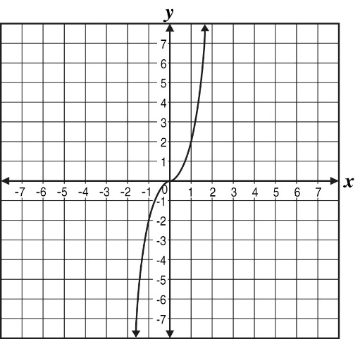  Which equation best represents this graph?
 | A. | $$y=-2x^{3}$$ | C. | $$y=-\frac{1}{2}x^{3}$$
 | B. | $$y=\frac{1}{8}x^{3}$$ | D. | $$y=2x^{3}$$

11. | 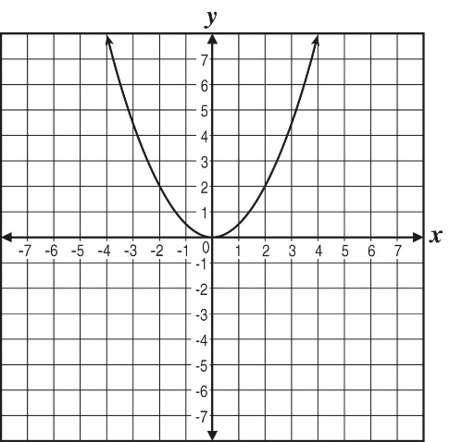  Which of the following functions does the graph represent?
 | A. | $$y=\frac{1}{2}x$$ | C. | $$y=\frac{1}{2}x^{3}$$
 | B. | $$y=\frac{1}{2}x^{2}$$ | D. | $$y=|\frac{1}{2}x|$$

12. | Which graph represents the equation $y=x^{2}$
 | A. | 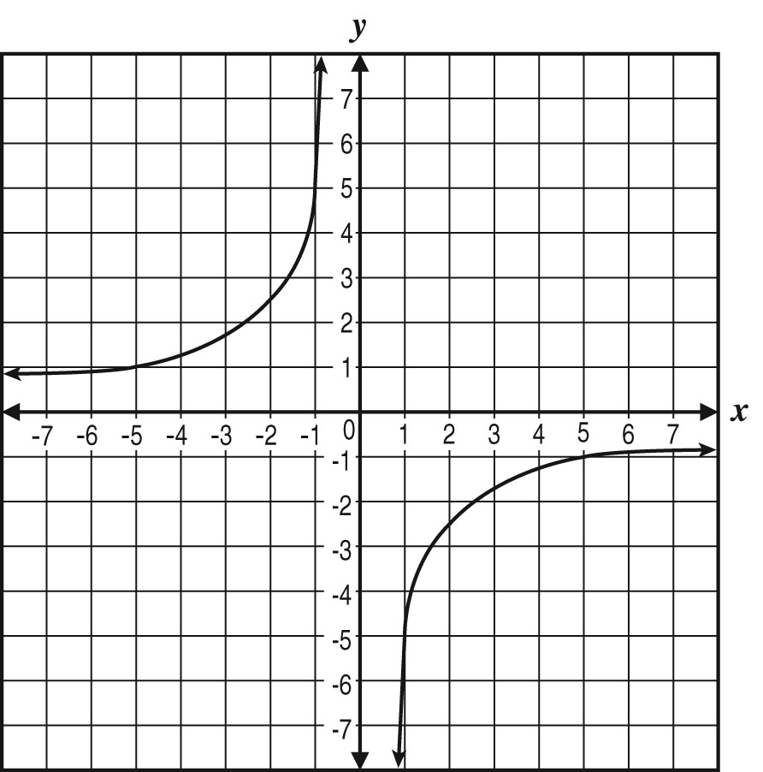 | C. | 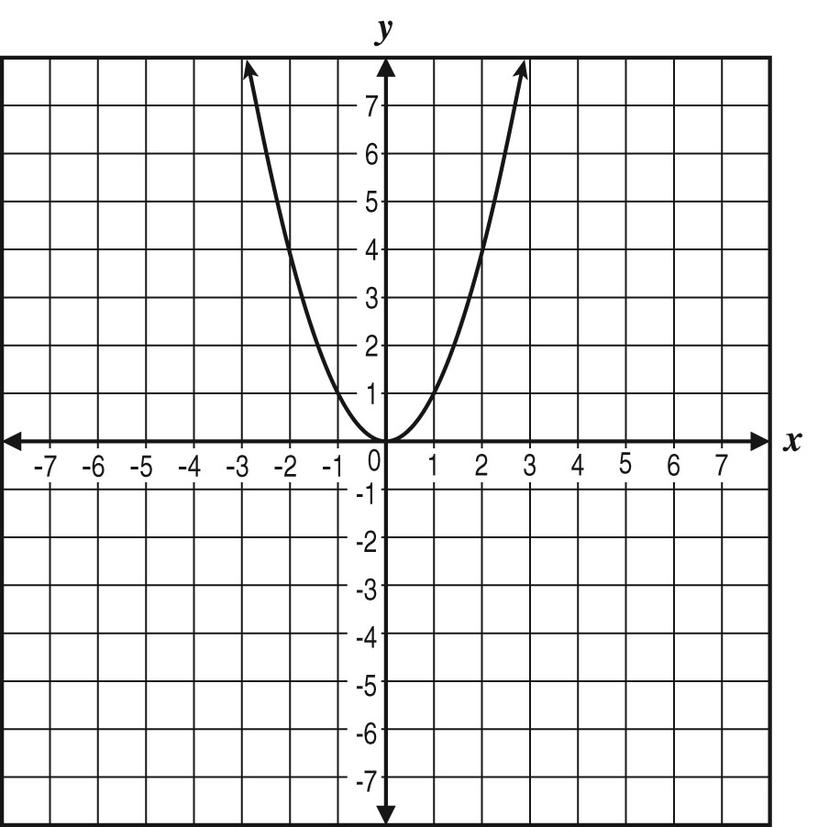
 | B. | 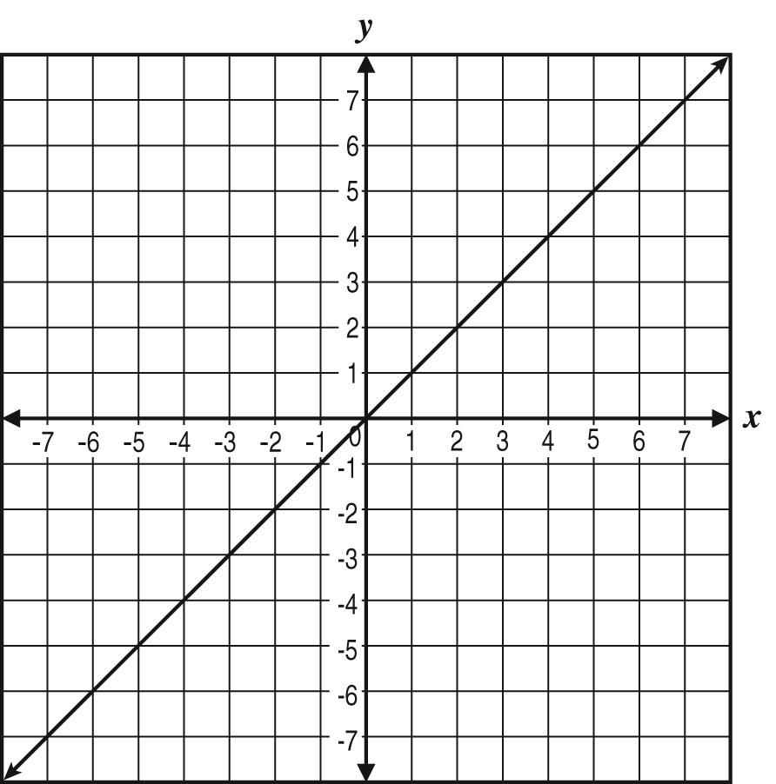 | D. | 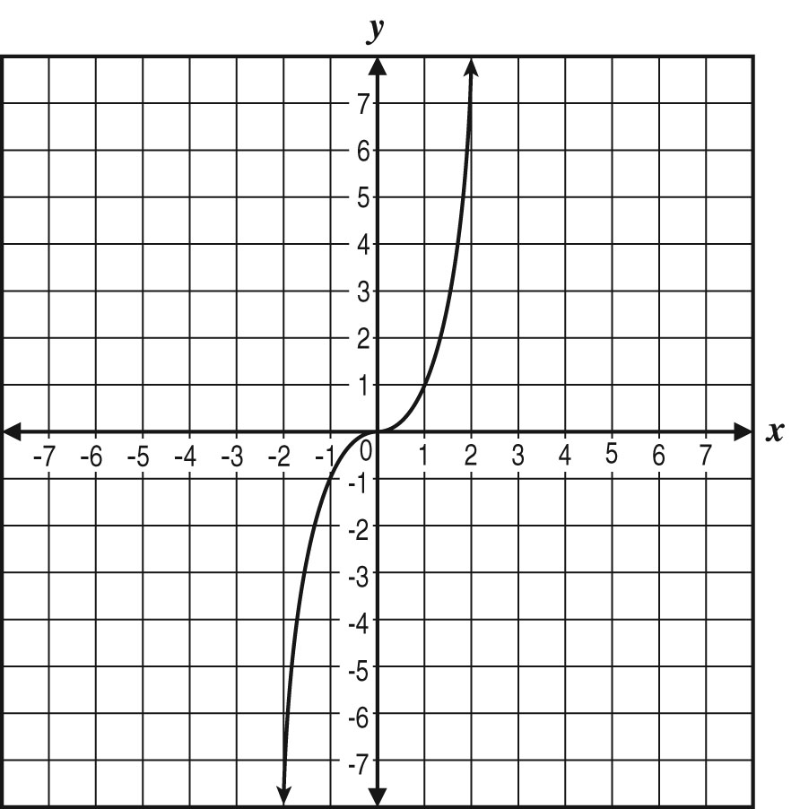

13. | 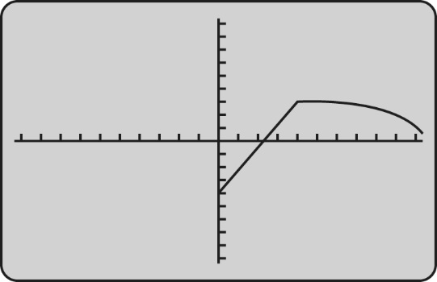  The graphing calculator screen displays data on the outdoor temperature in degrees Fahrenheit over several hours on a winter day. The horizontal axis represents time.  What does the graph indicate about the outdoor temperature over time?
 | A. | It got warmer at a constant rate, and then colder at a decreasing rate.
 | B. | It got warmer at a constant rate, and then colder at an increasing rate.
 | C. | It got warmer at an increasing rate, and then colder at a decreasing rate.
 | D. | It got warmer at an increasing rate, and then colder at an increasing rate.

14. | A piano teacher charges $25 for a half-hour lesson. Which graph represents the relationship between the time spent teaching piano and the teacher’s fee?
 | A. | 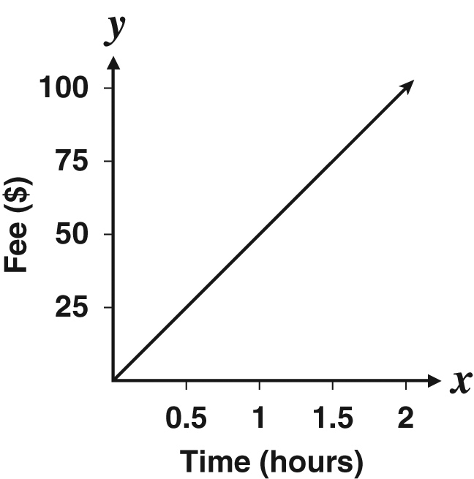 | C. | 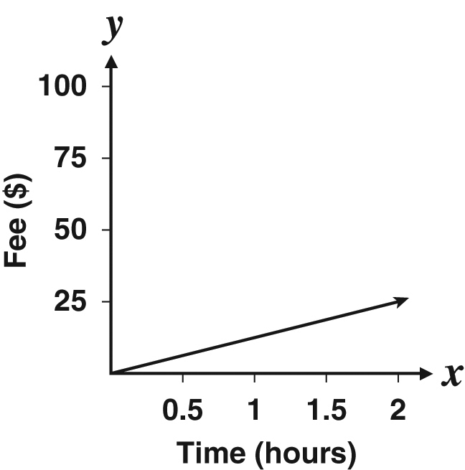
 | B. | 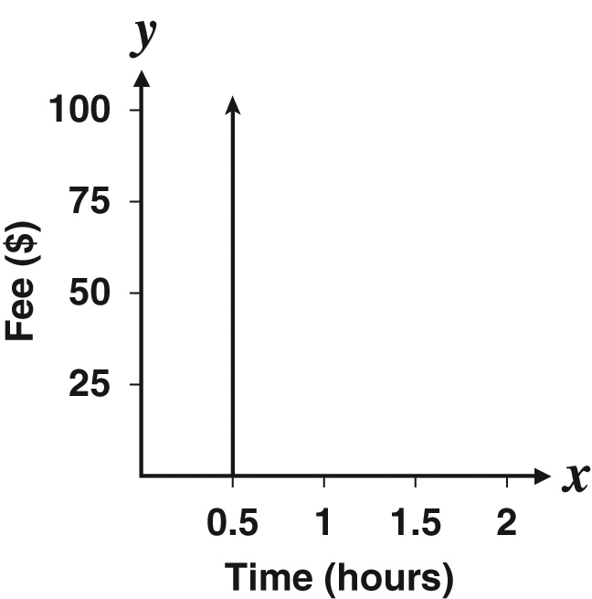 | D. | 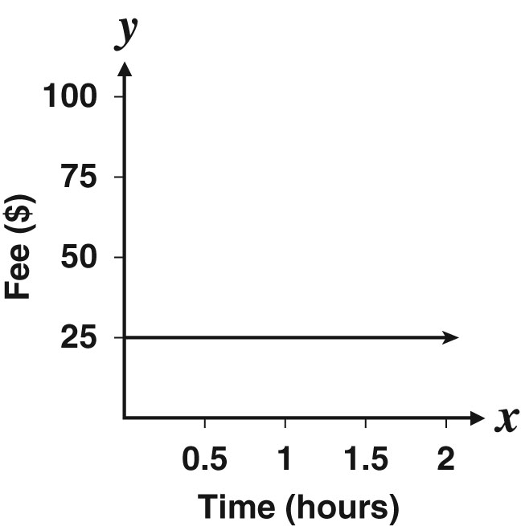

15. | The following equation is used to predict the cost, c , in dollars, to produce g units of some item.  $c=0.5g+12$ Which is a reasonable range for the cost to produce less than 100 items?
 | A. | $$0≤c<62$$ | C. | $$12<c≤62$$
 | B. | $$0<c≤62$$ | D. | $$12≤c<62$$

16. | x y  – 1 – 7  0 – 5  3 1  5 5  Which statement best describes the data in the table?
 | A. | The value of y is 6 less than the value of x .
 | B. | The value of y is 2 less than the value of x .
 | C. | The value of y is 5 less than twice the value of x .
 | D. | The value of y is 8 less than three times the value of x .

17. | If $f(x)=x^{2}-x$ what is f (−5)?
 | A. | $$-30$$ | C. | $$20$$
 | B. | $$-20$$ | D. | $$30$$

18. | What is the range of the function $y=3x-1$ for the domain $4≤x≤8?$
 | A. | $$\frac{4}{3}≤y≤\frac{8}{3}$$ | C. | $$2≤y≤4$$
 | B. | $$\frac{5}{3}≤y≤3$$ | D. | $$11≤y≤23$$

19. | The formula for the perimeter ( P ) of a rectangle is $P=2L+2W.$ What should be the first step when solving for W ?
 | A. | $$P+2L=2W$$ | C. | $$P+2W=2L$$
 | B. | $$P-2L=2W$$ | D. | $$P-2W=2L$$

20. | Coach Walker’s cheerleading team needs to raise money to pay for the entry fees to the state competition. There is a $99 team fee plus an individual fee for each cheerleader. Coach Walker found that the individual fees for her 18 cheerleaders will cost a total of $818.82. Which inequality can be used to find $m$, the least amount of money each cheerleader needs to raise in order to pay for both the team and individual entry fees?
 | A. | $$99m-18≥818.82$$ | C. | $$18m-99≥818.82$$
 | B. | $$99m-18≤818.82$$ | D. | $$18m-99≤818.82$$

21. | Hugh pays $9.99 a month for an online movie rental service. The service allows him to rent and watch movies for $0.89 each. If Hugh has set a budget of $30 per month for the movie service, which inequality can he use to find $m$, the maximum number of movies he can rent each month?
 | A. | $$0.89m+9.99≤30$$ | C. | $$0.89m+9.99<30$$
 | B. | $$0.89m-9.99≤30$$ | D. | $$0.89m-9.99<30$$

22. | The total number of students who could attend a field trip is represented by the variable t . The number of students in Group A is less than the number in Group B. Group A has 6 students more than $\frac{1}{4}$ the total number of students, while Group B has 3 less than the total number of students. Which inequality represents this situation?
 | A. | $$\frac{1}{4}t+6<t-3$$ | C. | $$\frac{1}{4}t+6<3-t$$
 | B. | $$\frac{1}{4}+6t<t-3$$ | D. | $$6t+\frac{1}{4}<t-3$$

23. | If 5 more than 5 times a number is 20, what is the number? Write and solve an equation.
 | A. | $$-5$$ | C. | $$3$$
 | B. | $$-3$$ | D. | $$5$$

24. | Alan has a business mowing lawns for $20 per lawn and raking leaves for $0.75 per pile. His goal is to earn exactly $30 each time he mows a lawn and rakes leaves. If x represents the number of piles of leaves, which equation models Alan’s goal?
 | A. | $$x+20=30$$ | C. | $$0.75x+20=30$$
 | B. | $$75x+30=20$$ | D. | $$30x+20=0.75$$

25. | 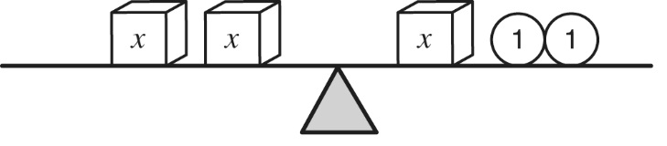  The diagram below models an equation.  Which would be the best first step to find the value of x ?
 | A. | add one x cube to each side of the scale
 | B. | add two x cubes to the right side of the scale
 | C. | remove one x cube from each side of the scale
 | D. | remove two circles labeled 1 from the right side of the scale

26. | What is x if $-3x-10<6$
 | A. | $$x>-\frac{16}{3}$$ | C. | $$x>\frac{4}{3}$$
 | B. | $$x<-\frac{16}{3}$$ | D. | $$x<\frac{4}{3}$$

27. | Which inequality has its solution shown on this number line?  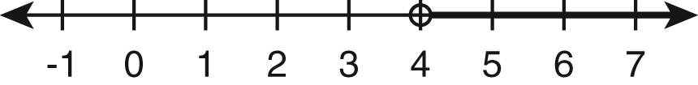
 | A. | $$2x+7>-15$$ | C. | $$-2x-7>-15$$
 | B. | $$2x-7>-15$$ | D. | $$-2x-7<-15$$

28. | 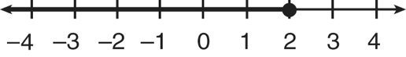  The number line represents the solution to which inequality?
 | A. | $$9≤2x+5$$ | C. | $$-8x+20≥-2(x-4)$$
 | B. | $$8x+2<18$$ | D. | $$7(x+2)≤4(2x+3)$$

29. | The graph of which equation includes the points (0, 10) and (10, 11)?
 | A. | $$y=10x+11$$ | C. | $$y=\frac{1}{10}x+10$$
 | B. | $$y=x+10$$ | D. | $$y=\frac{1}{10}x+11$$

30. | 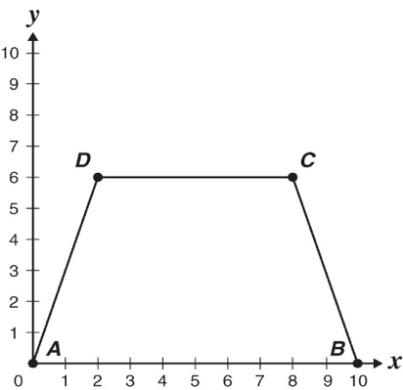  Trapezoid ABCD is drawn on a coordinate grid below. The coordinates for A , B , C, and D are (0, 0), (10, 0), (8, 6), and (2, 6) respectively.  What is the equation for the line containing $\overset{____}{CB}$
 | A. | $$y=30x-3$$ | C. | $$y=-3x-30$$
 | B. | $$y=3x+30$$ | D. | $$y=-3x+30$$

31. | If 1 more than 5 times a number is 26, what is the number? Write and solve an equation.
 | A. | $$-\frac{27}{5}$$ | C. | $$5$$
 | B. | $$-5$$ | D. | $$\frac{27}{5}$$

32. | This equation is used to convert Celsius temperatures into Fahrenheit temperatures.  $F=\frac{9}{5}C+32$ If $-273.15<C<100$what is the range in Fahrenheit?
 | A. | $$-273.15<F<100$$ | C. | $$-459.67<F<100$$
 | B. | $$-273.15<F<212$$ | D. | $$-459.67<F<212$$

33. | The pressure a shoe heel applies to the floor depends on the weight on the heel and the surface area of the tip of the heel. The equation below can be used to find p , the pressure applied, based on w , the weight, and a , the surface area of the tip of the heel.  $p=\frac{w}{a}$Which equation is equivalent when solved for w in terms of p and a ?
 | A. | $$w=pa$$ | C. | $$w=\frac{a}{p}$$
 | B. | $$w=\frac{p}{a}$$ | D. | $$w=p+a$$

34. | If 4 more than 3 times a number is 7, what is the number? Write and solve an equation.
 | A. | $$\frac{11}{3}$$ | C. | $$-1$$
 | B. | $$1$$ | D. | $$-\frac{11}{3}$$

35. | The weight, in pounds, of a baby in the first six months of life can be modeled by the function $f(x)=1.5x+7$, where x is the age of the baby in months. According to this model, what is the weight, in pounds, of a baby at age 5 months?
 | A. | 8.5 | C. | 13.5
 | B. | 12.0 | D. | 14.5

36. | The tables show telephone charges for different companies. Which table shows a linear relationship between the length of the call and the cost?
 | A. | Telephone Charges  Length of Call (minutes) Cost of Call (cents)  5 10  10 30  15 60  20 100  C. Telephone Charges  Length of Call (minutes) Cost of Call (cents)  5 5  10 10  15 45  20 80
 | B. | Telephone Charges  Length of Call (minutes) Cost of Call (cents)  5 15  10 25  15 75  20 80  D. Telephone Charges  Length of Call (minutes) Cost of Call (cents)  5 25  10 50  15 75  20 100

37. | 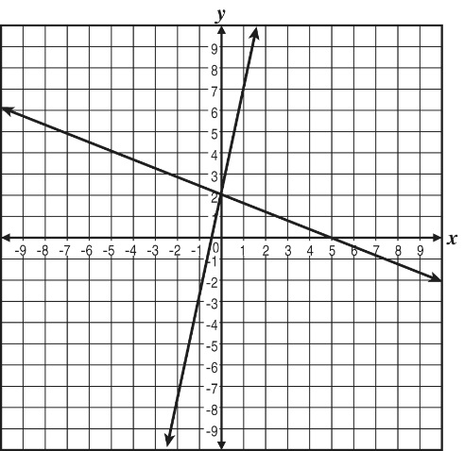  What do the two lines in the graph below have in common?
 | A. | y -intercept | C. | equation of the lines
 | B. | slope | D. | x -intercept

38. | In the inequality below, let x represent the number of pies a bakery makes each day.  $3x+18≤300$ Which of the following phrases most accurately describes the number of pies the bakery makes each day?
 | A. | more than 94 pies | C. | at most 94 pies
 | B. | exactly 94 pies | D. | less than 94 pies

39. | If 4( x – 3) = 5 x + 2, then x =
 | A. | $$-14$$ | C. | $$-1$$
 | B. | $$-5$$ | D. | $$-\frac{1}{9}$$

40. | A system of equations is given below.  $\{\begin{matrix}5x-2y=3 \\ 3x-y=4\end{matrix}$Which of these procedures will eliminate a variable in one of the equations in the system above?  Then solve the system.
 | A. | Multiply the first equation by 2 then add the result to the second equation.
 | B. | Multiply the first equation by –2 then add the result to the second equation.
 | C. | Multiply the second equation by 2 then add the result to the first equation.
 | D. | Multiply the second equation by –2 then add the result to the first equation.

41. | 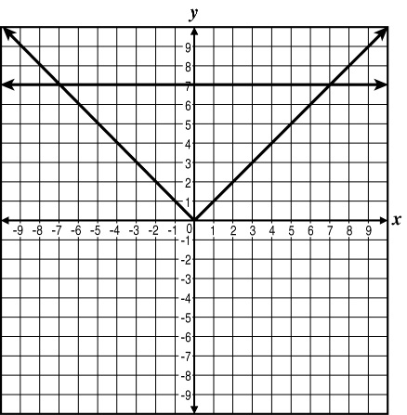  The graphs of $f(x)=7$ and $g(x)=|x|$ are shown below.  Which statement explains why 7 is an x -coordinate of a solution to the system of functions?
 | A. | A solution to a system is where the functions have the same y -value. Since both functions have a y -value of 7, a solution must be $x=7$.
 | B. | There are always two solutions to absolute value functions. Since $x=-7$is one solution, it follows that its opposite, $x=7$, is the other solution.
 | C. | A solution to a system is an x -coordinate where the graphs intersect. Since both graphs have the same y -value at $x=7$, a solution must be $x=7$.
 | D. | There are always two solutions when a horizontal line intersects an absolute value function. Since the horizontal line has a y -value of 7, the x -coordinate of the solutions must be $x=-7$and $x=7$.

42. | The perimeter of a square can be found with the formula $P=4s$where s is the length of one side in units.  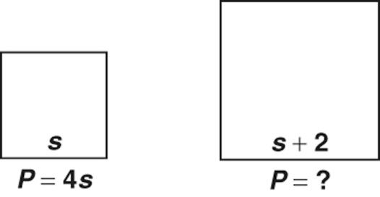  If s is increased by 2 units, what will be the perimeter of the new square?
 | A. | $$s+2$$ | C. | $$4s+2$$
 | B. | $$s+8$$ | D. | $$4s+8$$

43. | 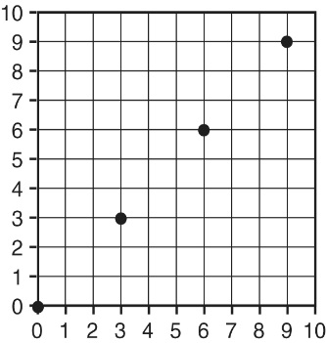  Which rule is shown on the graph below?
 | A. | $$y=x+3$$ | C. | $$y=3x$$
 | B. | $$y=x$$ | D. | $$y=x-3$$

44. | Which statement represents a situation in which a quantity is changing at a constant rate per unit interval?
 | A. | Bacteria in a petri dish triple every 12 hours.
 | B. | Water in a pool is draining $20 {in}^{3}$every 5 seconds.
 | C. | Money in a savings account is compounded daily at 3.5% interest.
 | D. | The braking distance of a car is proportional to the square of its speed.

45. | Which situation can be represented with a linear graph where the volume of water in a tub is a function of time?
 | A. | A faucet pumps water into a tub at a rate of 2 gallons per minute.
 | B. | A tub loses one-fifth of the remaining water each minute as it is drained.
 | C. | A tub is filled at a rate of 2 gallons per minute and then drained at a rate of 3 gallons per minute.
 | D. | A faucet pumps water into a tub at a rate of 3 gallons per minute as 5% of its volume is drained per minute.

46. | How many solutions does the equation$\left| 3x-8\right|=-4$ have?
 | A. | 3 | C. | 1
 | B. | 2 | D. | 0

47. | Find all possible values of x for the following absolute value inequality.  $$|3x-4|<8$$
 | A. | $$x<4$$ | C. | $$x<4 and x>-\frac{4}{3}$$
 | B. | $$x>-\frac{4}{3}$$ | D. | $$x<4 or x>-\frac{4}{3}$$

48. | What are the x - and y -intercepts of the line $y=2x-12$
 | A. | x -intercept = $-6$; y -intercept = $12$ | C. | x -intercept = $-12$; y -intercept = $6$
 | B. | x -intercept = $6$; y -intercept = $-12$ | D. | x -intercept = $12$; y -intercept = $-6$

49. | What are the x - and y -intercepts for $-x+2y=8?$
 | A. | x -intercept = $-8$; y -intercept = $4$ | C. | x -intercept = $4$; y -intercept = $-8$
 | B. | x -intercept = $4$; y -intercept = $8$ | D. | x -intercept = $8$; y -intercept = $-4$

50. | Two trains, 165 miles apart, travel toward each other in a straight line from opposite directions. The commuter train is traveling due north at an average speed of 65 miles per hour. The express train is traveling due south at an average speed of 75 miles per hour. If both trains left at the same time, in how many minutes will the trains be 25 miles apart?
 | A. | 57.5 | C. | 82.5
 | B. | 60 | D. | 95

51. | Rosa is graphing the following ordered pairs:  (1, 7), (2, 11), (3, 15), (4, 19) Which of these equations could Rosa be graphing?
 | A. | $$y=4x+3$$ | C. | $$y=2x+11$$
 | B. | $$y=3x+4$$ | D. | $$y=x+6$$

52. | Which property is illustrated below?  $$7(\frac{1}{3}+\frac{1}{5})=7×\frac{1}{3}+7×\frac{1}{5}$$
 | A. | commutative property | C. | associative property
 | B. | distributive property | D. | identity property

53. | Which of the following illustrates the distributive property of real numbers?
 | A. | 8 + 3 = 3 + 8 | C. | 5(3 + 2) = 15 + 10
 | B. | 0 × 7 = 0 | D. | $$9+(4+1)=(9+4)+1$$

54. | Which of the following equations is an example of the distributive property?
 | A. | $$r(s+t)=rs+rt$$ | C. | $$x+(y+z)=(x+y)+z$$
 | B. | $$a(bc)=(ab)c$$ | D. | $$b(c+d)=b(d+c)$$

55. | Two trains left a station at the same time traveling in opposite directions. The northbound train traveled at an average rate of 50 miles per hour (mph). The southbound train traveled at an average rate of 40 mph. After how many hours will the trains be 225 miles apart?
 | A. | $$\frac{2}{5}$$ | C. | $$4\frac{1}{2}$$
 | B. | $$2\frac{1}{2}$$ | D. | $$5\frac{5}{8}$$

56. | 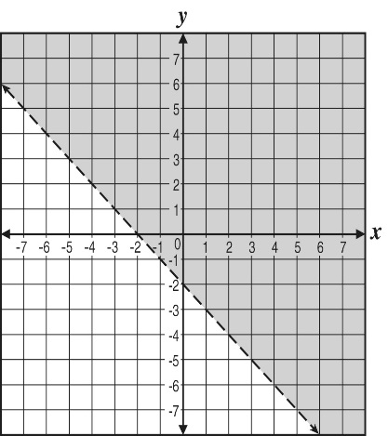  Which inequality is shown in the graph?
 | A. | $$y+x<-2$$ | C. | $$y+x<2$$
 | B. | $$y+x>-2$$ | D. | $$y+x>2$$

57. | 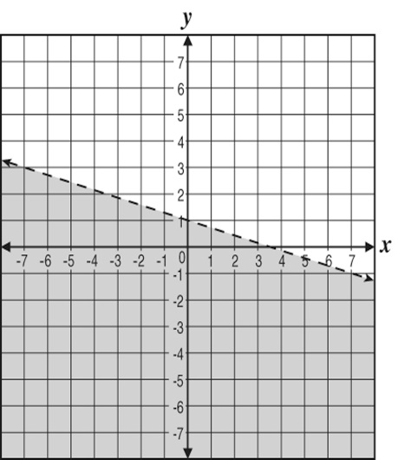  The shaded region of the graph represents which inequality?
 | A. | $$2x+7y≥7$$ | C. | $$2x+7y>7$$
 | B. | $$2x+7y≤7$$ | D. | $$2x+7y<7$$

58. | The shaded portion of which graph best represents the solution to the inequality $2y-x≤4$
 | A. | 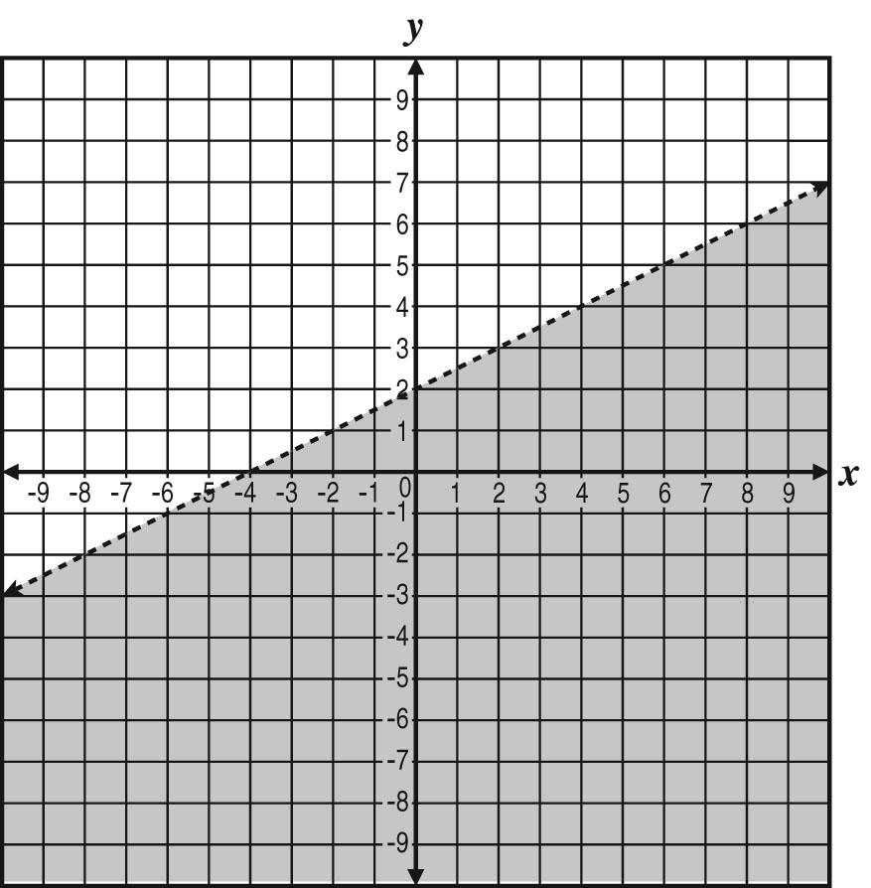 | C. | 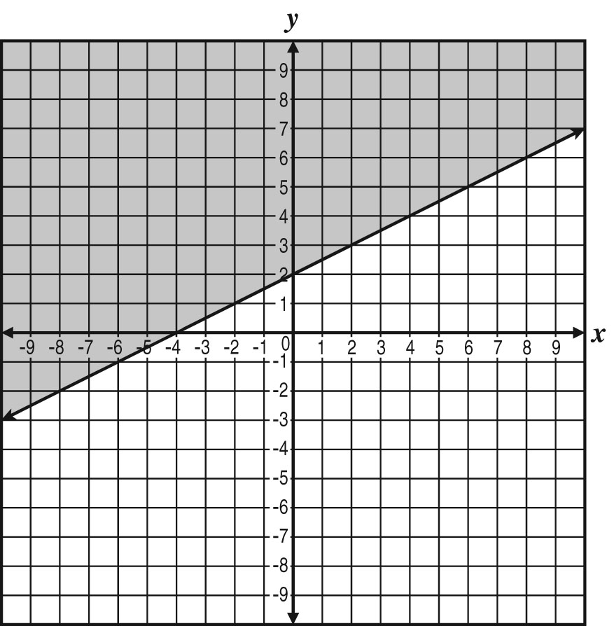
 | B. | 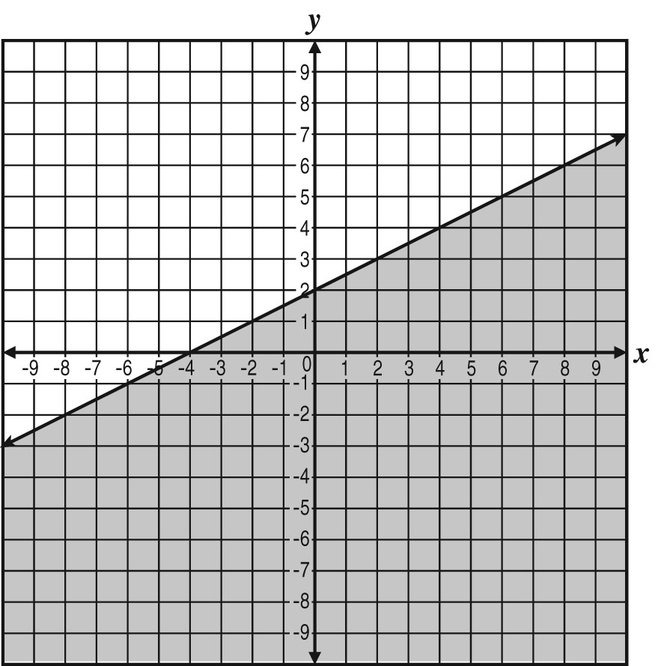 | D. | 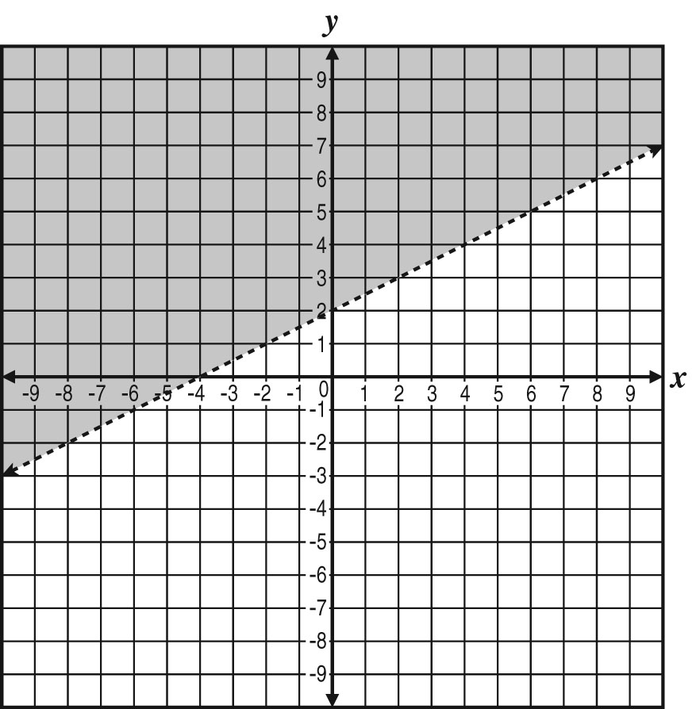

59. | Which pair of values for x and y will not satisfy the following system?  $$\begin{matrix}y<2x-1 \\ y>x-1\end{matrix}$$
 | A. | x = 1, y = 1 | C. | x = 5, y = 7
 | B. | x = 3, y = 4 | D. | x = 6, y = 6

60. | Which of the following inequalities has a solution set as shown in the graph below?  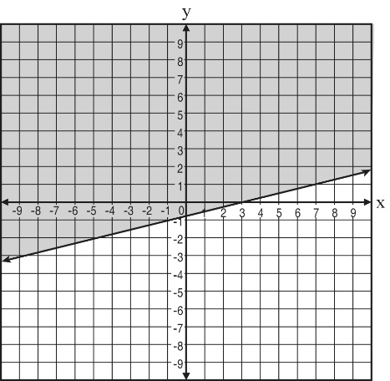
 | A. | $$y≥-\frac{1}{4}x-\frac{3}{4}$$ | C. | $$y≤\frac{1}{4}x-\frac{3}{4}$$
 | B. | $$y≤-\frac{1}{4}x-\frac{3}{4}$$ | D. | $$y≥\frac{1}{4}x-\frac{3}{4}$$

61. | Which graph represents the equation $y+2=\frac{3}{4}(x-4)$
 | A. | 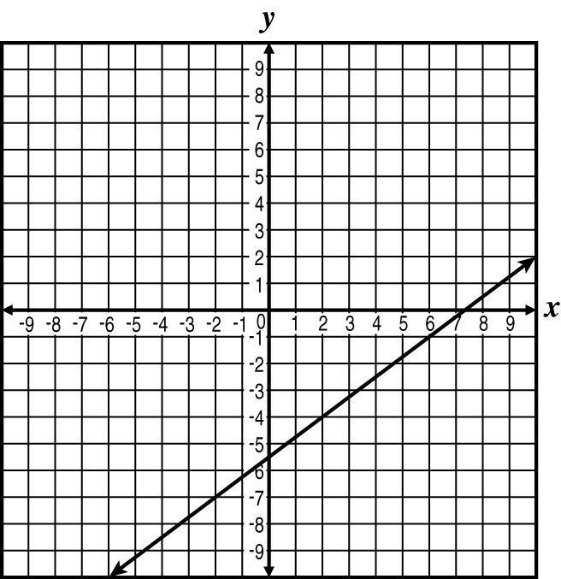 | C. | 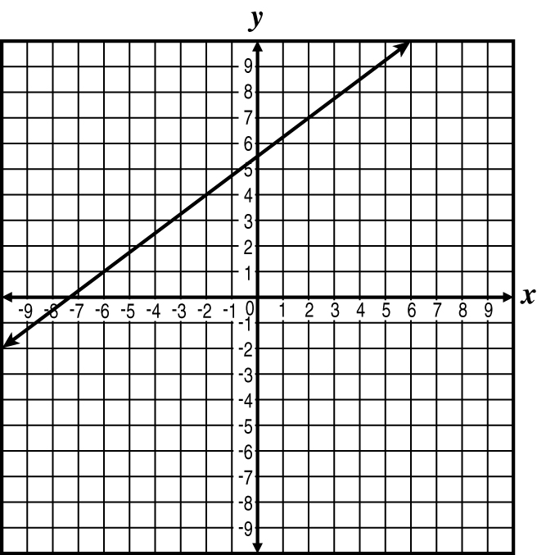
 | B. | 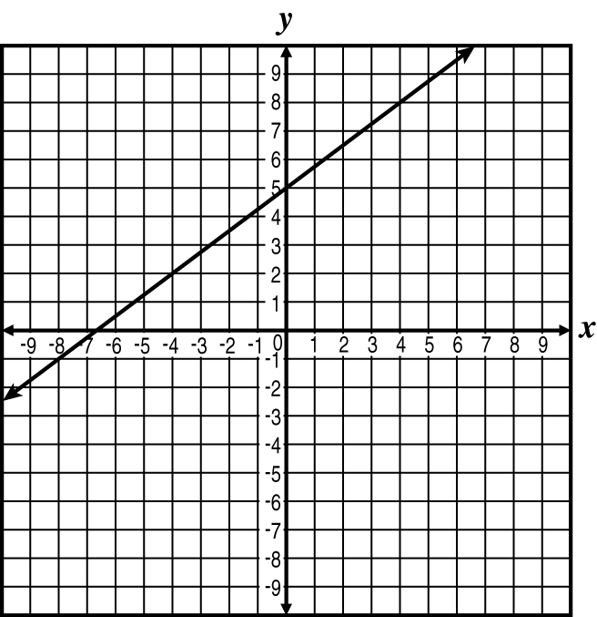 | D. | 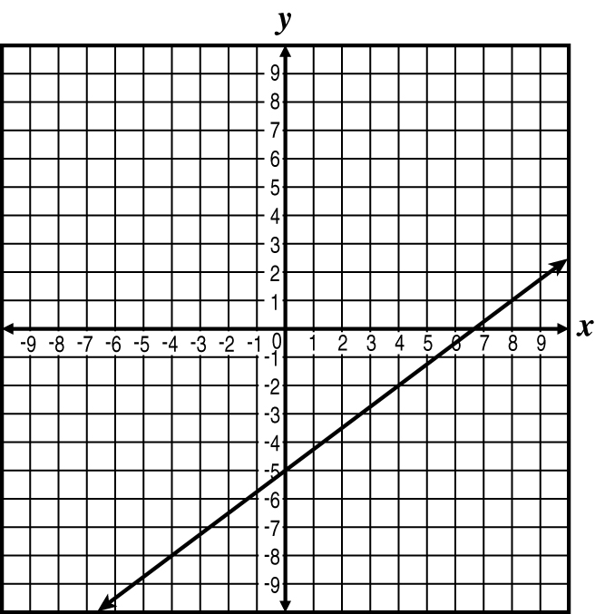

62. | Which coordinate pair represents the x -intercept of the graph of the equation $3x-2y=12$ in the coordinate plane?
 | A. | $$(-6,0)$$ | C. | $$(0,4)$$
 | B. | $$(0,-6)$$ | D. | $$(4,0)$$

63. | 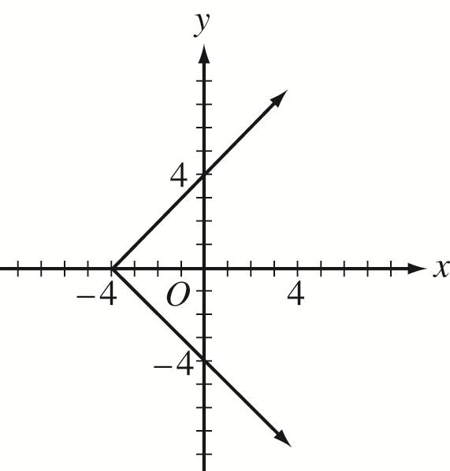  Which of the following is an equation of the graph in the figure below?
 | A. | $$x=|y-4|$$ | C. | $$y=|x-4|$$
 | B. | $$x=|y|-4$$ | D. | $$y=|x|-4$$

64. | 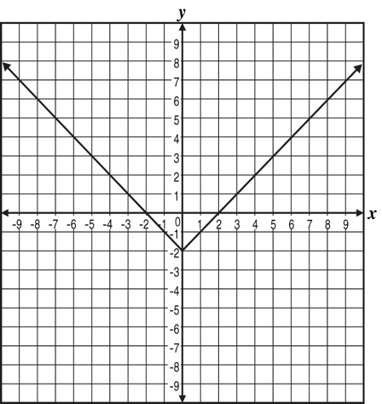  The graph of $y=|x|-2$ is shown below.  What is the value of y when x = 0?
 | A. | $$-2$$ | C. | $$0$$
 | B. | $$-1$$ | D. | $$2$$

65. | A bakery sells chocolate chip cookies and oatmeal cookies in packages of 12 each. On Saturday, the bakery sold half as many oatmeal cookies as chocolate chip cookies. If the total number of cookies sold on Saturday was 504, how many packages of chocolate chip cookies were sold?
 | A. | 7 | C. | 28
 | B. | 14 | D. | 42

66. | 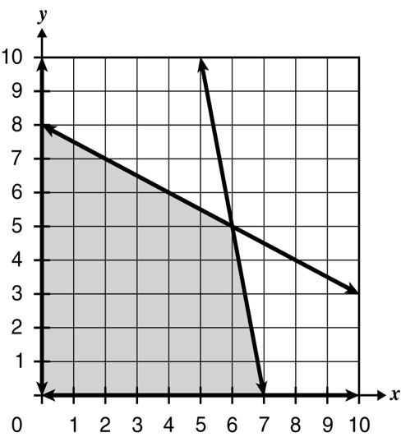  The graph of a system of linear inequalities is shown.  What are the constraints to the system of linear equations?
 | A. | $$\begin{matrix}x≥0 \\ y≥0 \\ x+2y≤16 \\ 5x+y≤35\end{matrix}$$ | C. | $$\begin{matrix}x≥0 \\ y≥0 \\ x+2y≥16 \\ 5x+y≥35\end{matrix}$$
 | B. | $$\begin{matrix}x≤0 \\ y≤0 \\ x+2y≤16 \\ 5x+y≤35\end{matrix}$$ | D. | $$\begin{matrix}x≤0 \\ y≤0 \\ x+2y≥16 \\ 5x+y≥35\end{matrix}$$

67. | Jay wants to rent a car. The company he will rent from uses the formula C = 25 + 0.40 m to determine rental cost, where C represents the total cost in dollars and m represents the number of miles driven. Which statement is true given this information?
 | A. | There is a $25.40 cost per day. | C. | The 0.40 means there is an initial charge of $40.
 | B. | The 25 means there is an initial charge of $25. | D. | The 25 means the charge for each mile is 25 cents.

68. | Ruby bought an animal bank for her nephew. She is the only one who puts money in the bank, and no money is taken out. The function $f(v)=10+2v$ describes the amount in the bank after v visits with her nephew. Which statement is true?
 | A. | Ruby puts $2 in the bank each visit. | C. | There was $2 in the bank before the first visit.
 | B. | Ruby puts $10 in the bank each visit. | D. | There was $12 in the bank before the first visit.

69. | The number of bottles of water in a pantry after a delivery can be modeled by the function $f(x)=24x+35$, where x is the number of cases of bottled water delivered. Which statement is true?
 | A. | Each case of water contains 24 bottles. | C. | There were 24 bottles of water in the pantry before the delivery.
 | B. | Each case of water contains 35 bottles. | D. | There were 59 bottles of water in the pantry before the delivery.

70. | Kiyoshi is replacing some of the flooring in his house. He will need 200 square feet of hardwood flooring and 350 square feet of carpet. He would like to determine the possible prices per square foot for both types of flooring, keeping the cost to no more than $2,000. Which inequality describes this situation?  x = price of hardwood flooring per square foot  y = price of carpeting per square foot
 | A. | $$350x+200y≥2000$$ | C. | $$200x+350y≤2000$$
 | B. | $$350x+200y≤2000$$ | D. | $$200x+350y≥2000$$

71. | Monika is in charge of ordering pens for an upcoming convention. Pens come in boxes of 6 and boxes of 8 and Monika needs at least 720 pens. Which inequality describes this situation?  x = number of boxes of 6 pens  y = number of boxes of 8 pens
 | A. | $$6x+8y≥720$$ | C. | $$6x+8y≤720$$
 | B. | $$8x+6y≥720$$ | D. | $$8x+6y≤720$$

72. | 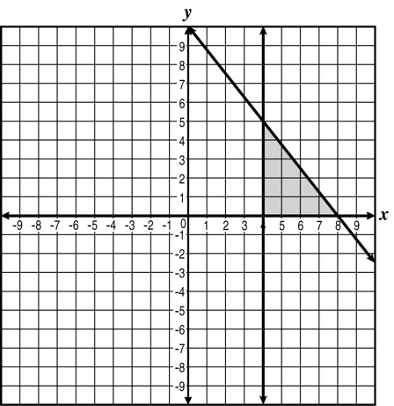  The graph of a system of inequalities is shown.  What are the constraints to the system?
 | A. | $$\begin{matrix}x≥4 \\ y≥0 \\ 5x-4y≤40\end{matrix}$$ | C. | $$\begin{matrix}x≥4 \\ y≥0 \\ 5x+4y≤40\end{matrix}$$
 | B. | $$\begin{matrix}x≥0 \\ y≥4 \\ 5x+4y≤40\end{matrix}$$ | D. | $$\begin{matrix}x≥0 \\ y≥4 \\ 5x-4y≤40\end{matrix}$$

73. | The expression below best represents which property?  $$n×6=6×n$$
 | A. | commutative property of multiplication | C. | associative property of multiplication
 | B. | distributive property of multiplication | D. | identity property for multiplication

74. | Which property is demonstrated by the equation $(5+a)+3=(a+5)+3$
 | A. | Commutative Property | C. | Associative Property
 | B. | Distributive Property | D. | Inverse Property

75. | Which table of values shows an inverse variation between x and y ?
 | A. | 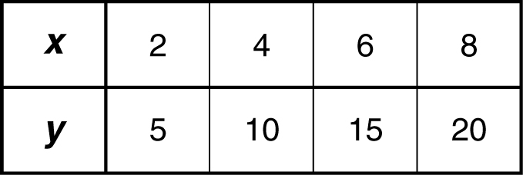 | C. | 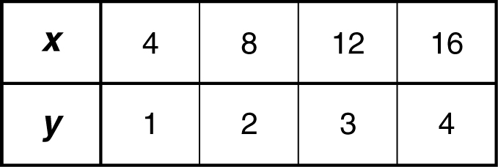
 | B. | 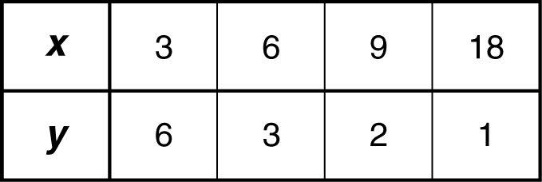 | D. | 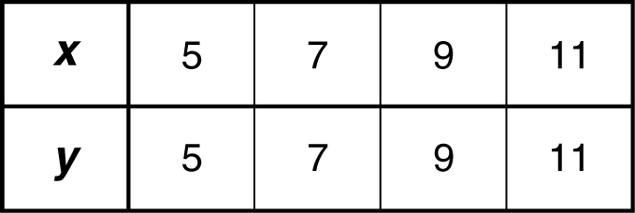

76. | What are the domain and range of the function shown on this graph?  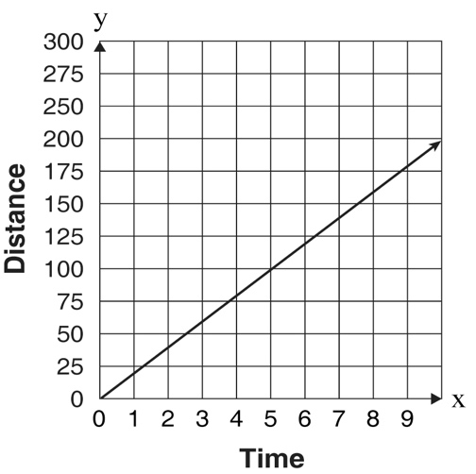
 | A. | Domain is $x≥0,$and range is $y≥0$
 | B. | Domain is $0≤x≤0,$and range is $0≤y≤200$
 | C. | Domain is $\{1,2,3,4,5,6,7,8,9\},$and range is $y≥0$
 | D. | Domain is all real numbers, and range is all real numbers.

77. | Which of the following is the range of the function $y=-2x^{2}+8x-5$ given the domain $-1≤x≤3$
 | A. | $$-15≤y≤1$$ | C. | $$-9≤y≤7$$
 | B. | $$-11≤y≤1$$ | D. | $$-15≤y≤3$$

78. | The tax rate in Terri’s county is given by the equation y = 0.06 x , where y represents the amount of tax in dollars and x represents the purchase price in dollars. Based on this equation, which statement is true?
 | A. | Both the domain and range are all real numbers.
 | B. | The domain is 0.06, and the range is all real numbers.
 | C. | Both the domain and range are greater than or equal to zero.
 | D. | The domain is greater than or equal to zero, and the range is all real numbers.

79. | What is the range of the following graph?  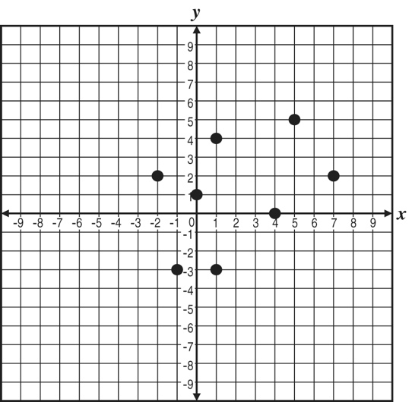
 | A. | $$\{-3,0,1,2,4,5\}$$ | C. | $$\{-2,-1,0,1,4,5,7\}$$
 | B. | $$\{-3≤y≤5\}$$ | D. | $$\{-2≤y≤7\}$$

80. | 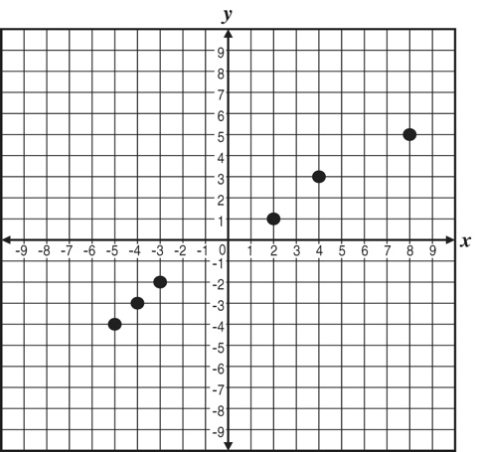  What is the domain of the following graph?
 | A. | $$\{-4,-3,-2,1,3,5\}$$ | C. | $$\{-5,-4,-3,2,4,8\}$$
 | B. | $$\{-4≤x≤5\}$$ | D. | $$\{-5≤x≤8\}$$

81. | Tony’s Corner Market sells bulk candy for $1.80 a pound. If the largest container holds at most 2.5 pounds and a customer purchases only 1 container, which statement best describes the possible domain and range values for this situation?
 | A. | The domain and range both consist of all values greater than and including 0.
 | B. | The domain and range both consist of all values greater than and including 1.80.
 | C. | The domain is all values less than and including 2.5, and the range is all values less than and including 4.50.
 | D. | The domain is all values between and including 0 and 2.5, and the range is all values between and including 0 and 4.50.

82. | Look at the system of equations below.  $$-8a+9b=12$$  $$3a+14=b$$  What is the value of b for the solution to this system of equations?
 | A. | 6 | C. | – 4
 | B. | 4 | D. | – 6

83. | The perimeter of a rectangular garden is 150 feet. The length is 20 feet longer than the width, w . Which equation can be used to calculate the width of the garden?
 | A. | $$2w+2(w+20)=150$$ | C. | $$2l+2(w+20)=150$$
 | B. | $$2(w-20)+2w=150$$ | D. | $$2(w+20)+2(w+20)=150$$

