Name___________________________
Due Date________________________
Hour____________________________
Function Rules, Tables, and Graphs Homework
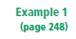
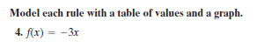
x | f(x) = - 3x | (x, f(x))
-1
0
1
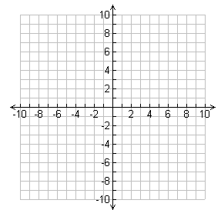

x | f(x) = -3x – 2 | (x, f(x))
-2
-1
0
1
x | f(x) = 8 – x | (x, f(x))
0
2
4
8

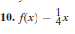
x | f(x) = $\frac{1}{4}$ x | (x, f(x))
-2
0
2
4

x | y = x + 4 | (x, y)
-3
-2
-1
0
1

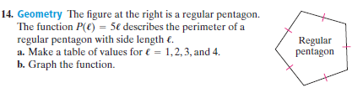
l | P(l) = 5l | (l, P(l))
1
2
3
4
x | y = $|x|$ + 2 | (x, y)
-2
-1
0
1
2

x | f(x) = x² - 1 | (x, f(x))
-2
-1
0
1
2

x | y = x² + 3 | (x, y)
-2
-1
0
1
2

x | f(x) = - x² – 1 | (x, f(x))
-2
-1
0
1
2

