Name_____________________
Due Date__________________
Hour______________________
Graphing Absolute Value Inequalities
Homework
Graph each inequality and write the solution. Tell if it is a conjunction or disjunction.

- |d| > 2
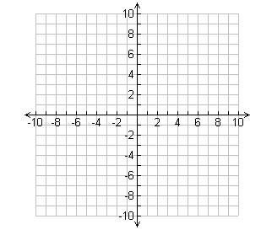
- |h| $>$ 6
- |s + 4| > 2
- |j| - 2 ≥ 6
- 5 > |v + 2| + 3
- -2|h - 2| > -2
- 3|s - 4| + 21 ≤ 27
- -6|w - 3| < -24
- |c| < 5
- |u| ≥ 1
- |a + 1| ≤ 2

