Name Date
Lesson
4.2
Extra Practice

Find the slope of the line.
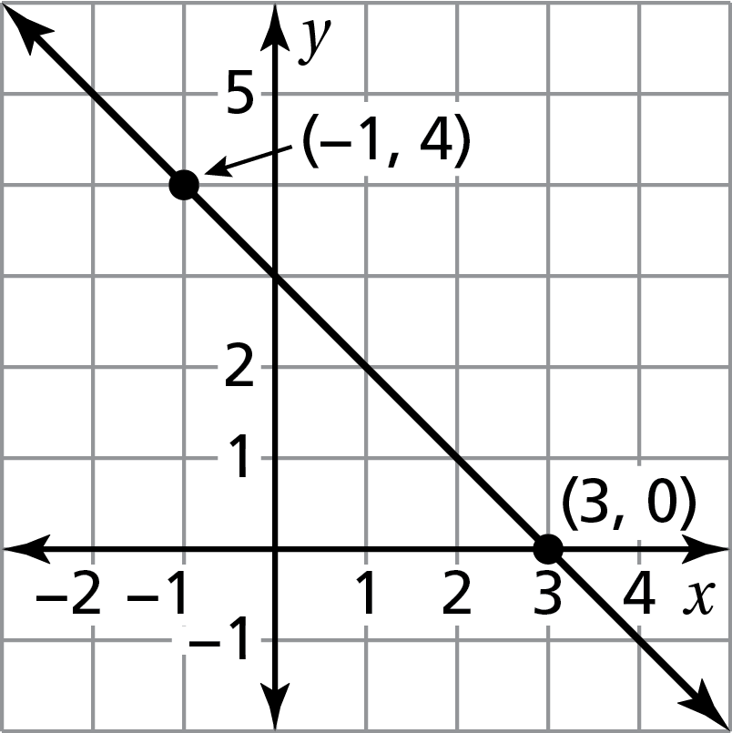
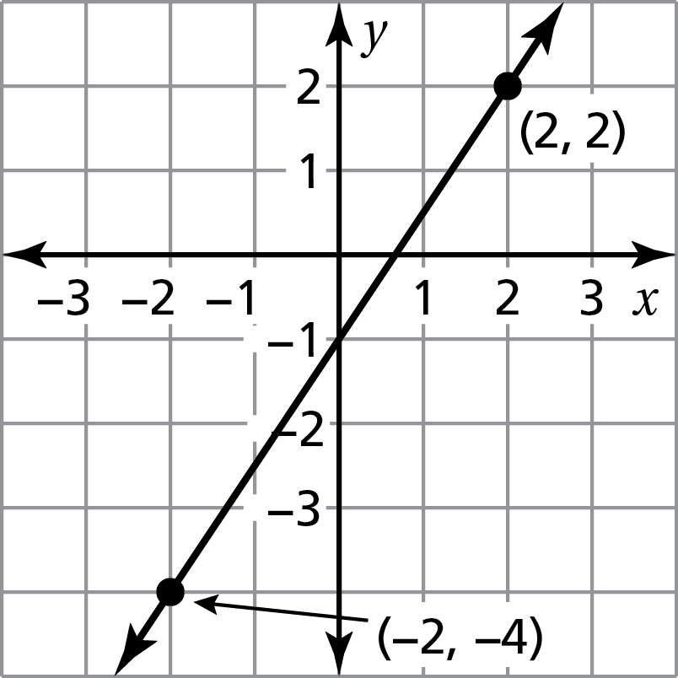
1. 2.

Find the slope of the line through the given points.
3. (−1, −4), (1, 4) 4. (1, 2), (−3, 2)
Which lines are parallel? How do you know?
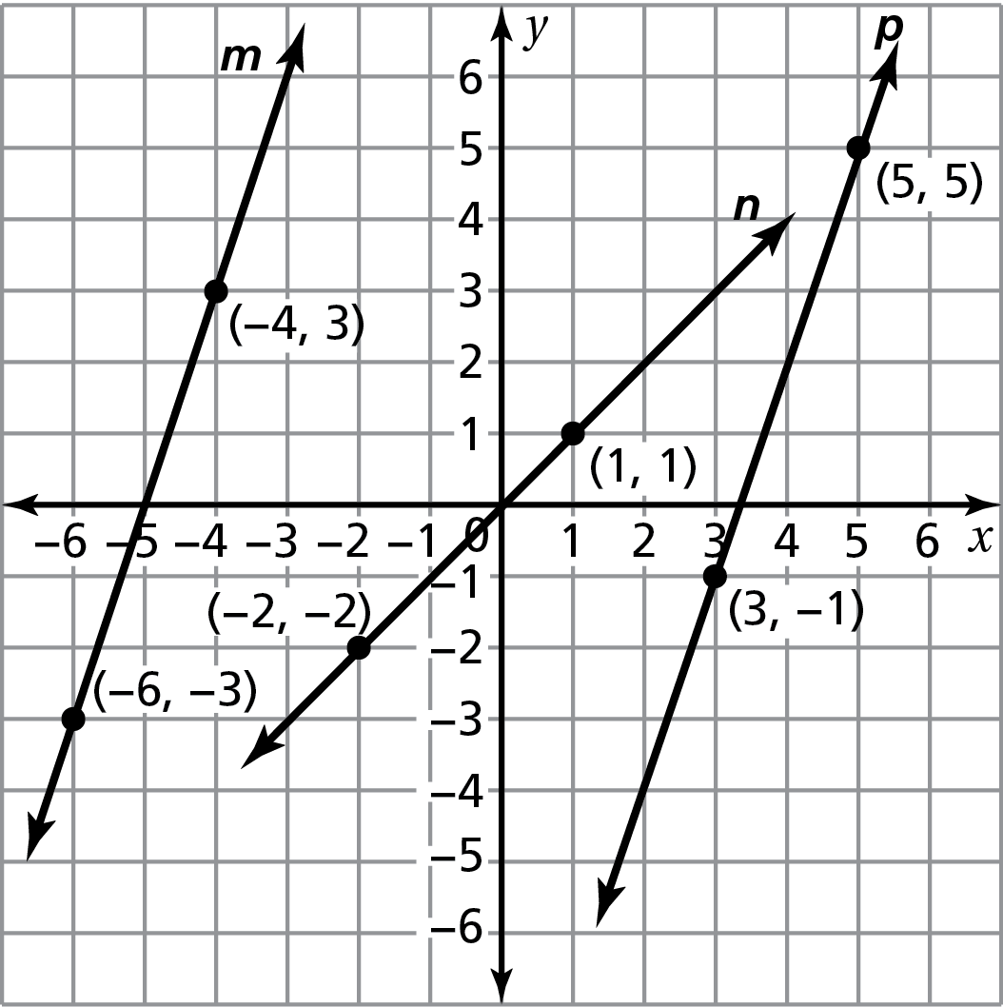
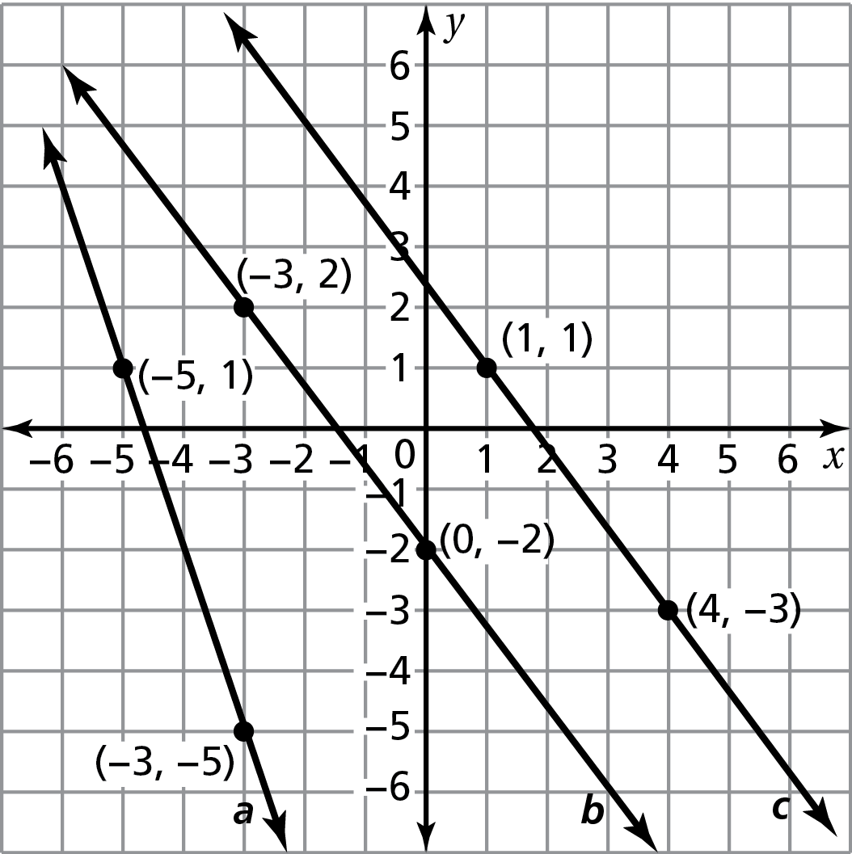
5. 6.

Are the given lines parallel? How do you know?
7. y = 0, x = 1 8. x = −2, x = 5
The points in the table lie on a line. Find the slope of the line.
9. 10.
x | −3 | 0 | −1 | 2
y | 6 | 3 | 2 | −1

x | 1 | 3 | 5 | 7
y | −7 | −2 | 3 | 8

11. An awning covers a window that is 4 feet high. When the awning is opened, it extends 2 feet from the base of the window. Find the slope of the awning.
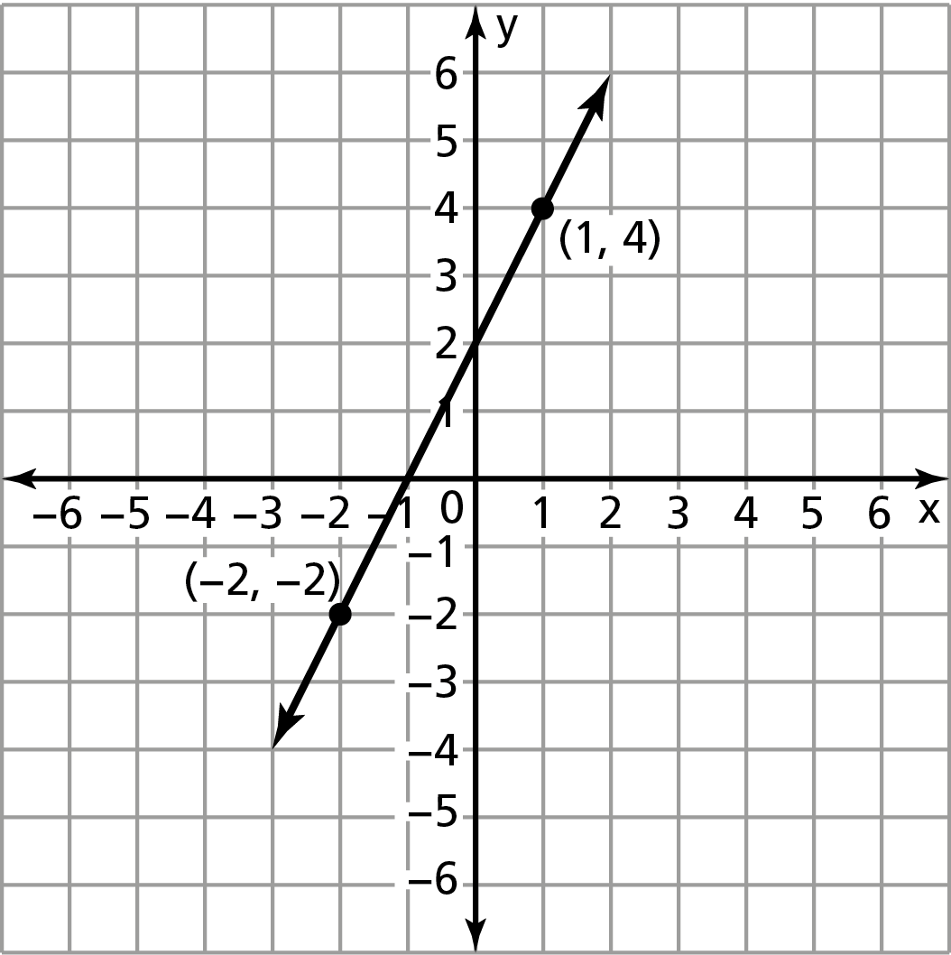
12. Your friend finds the slope of the line shown.
Is your friend correct? Explain your reasoning.
m = $\frac{-2-4}{-2-1}$
= $\frac{-6}{-3}$
= 2

