Name Date

4.2

puzzle

Puzzle Time

What Did One Poppy Seed Say To The Other?

Circle the letter of each correct answer in the boxes below. The circled letters will spell out the answer to the riddle.

Find the slope of the line through the given points.

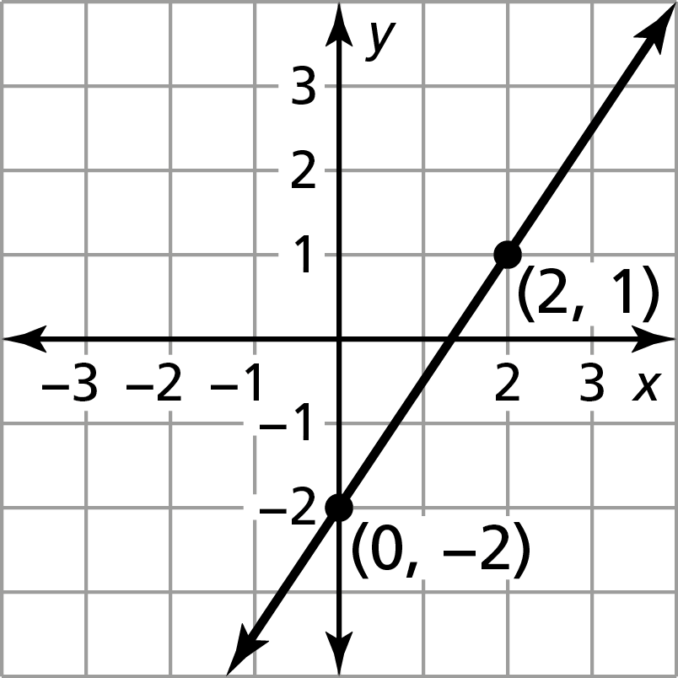 1. 2. 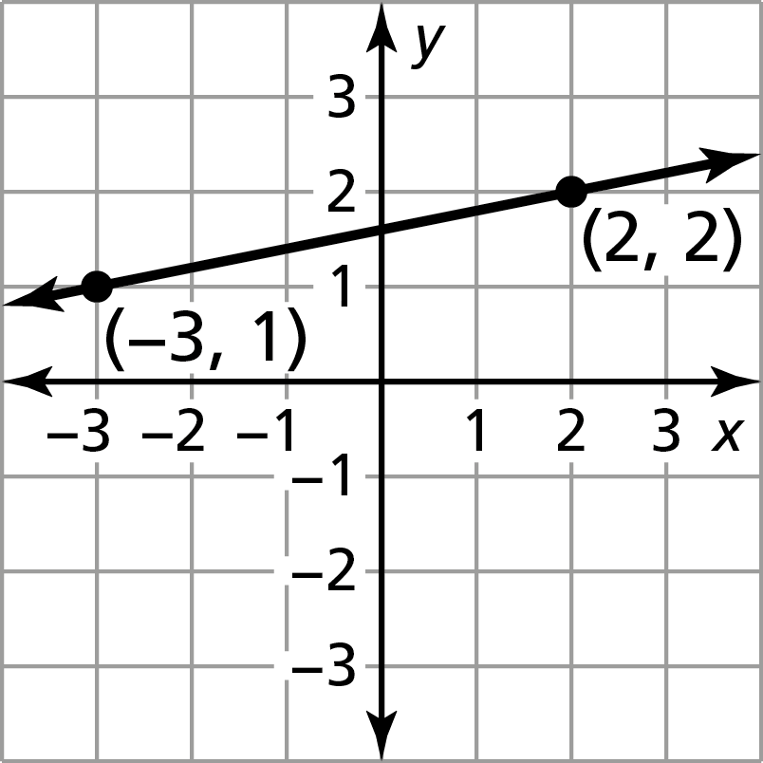 3. 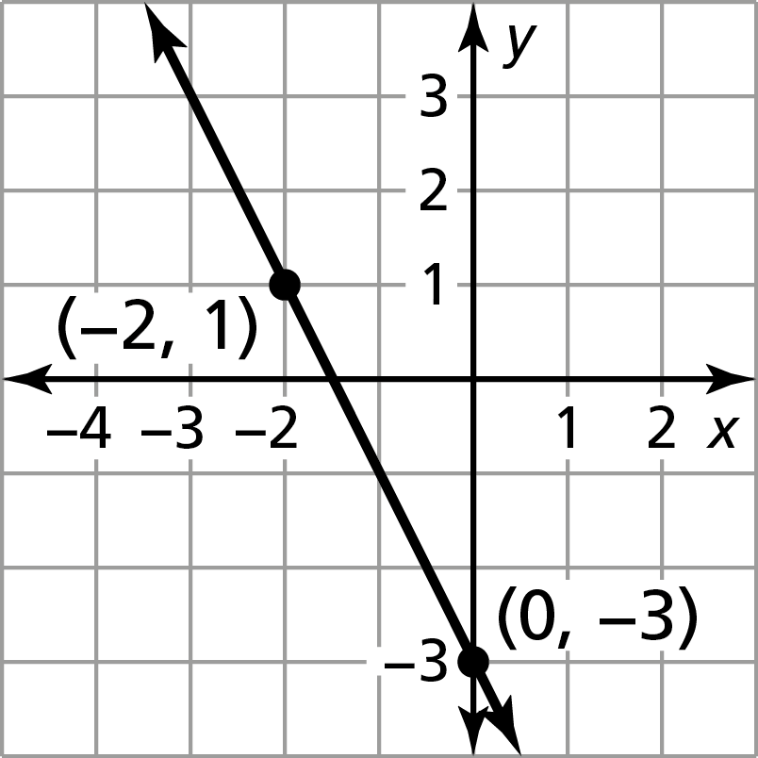

4. 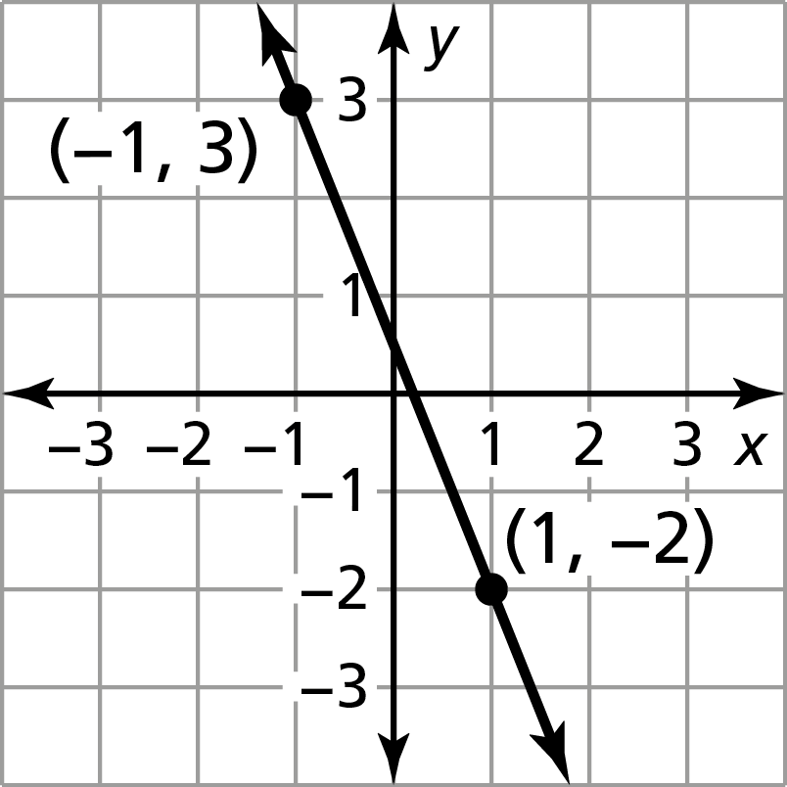 5. 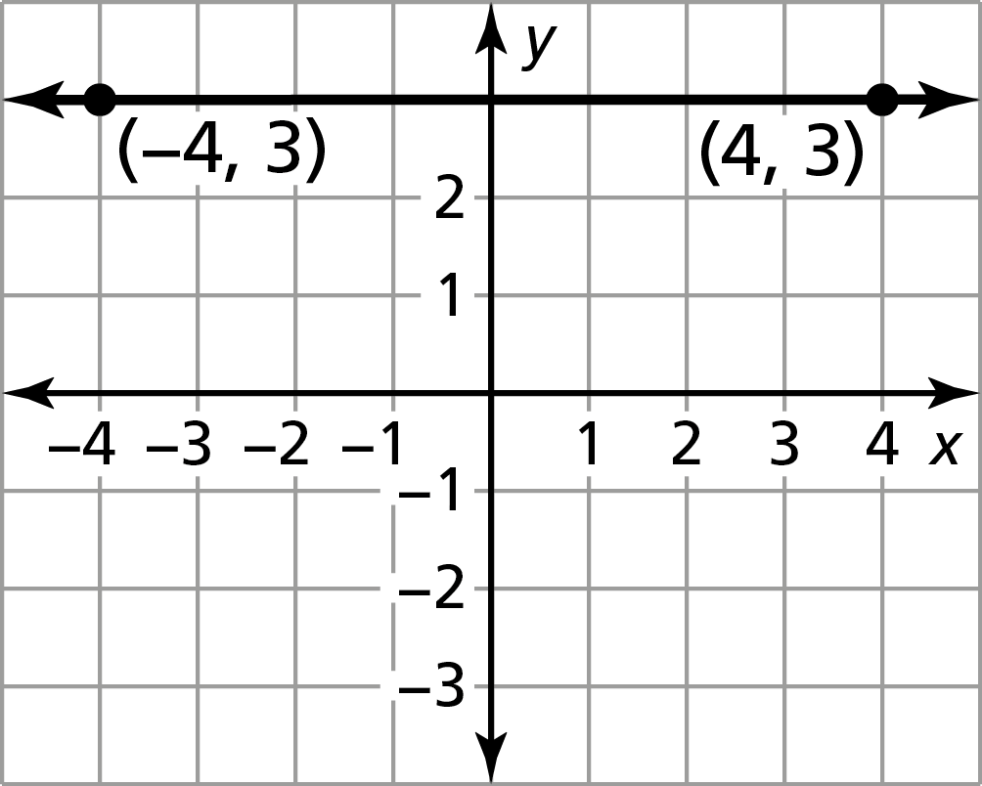 6. 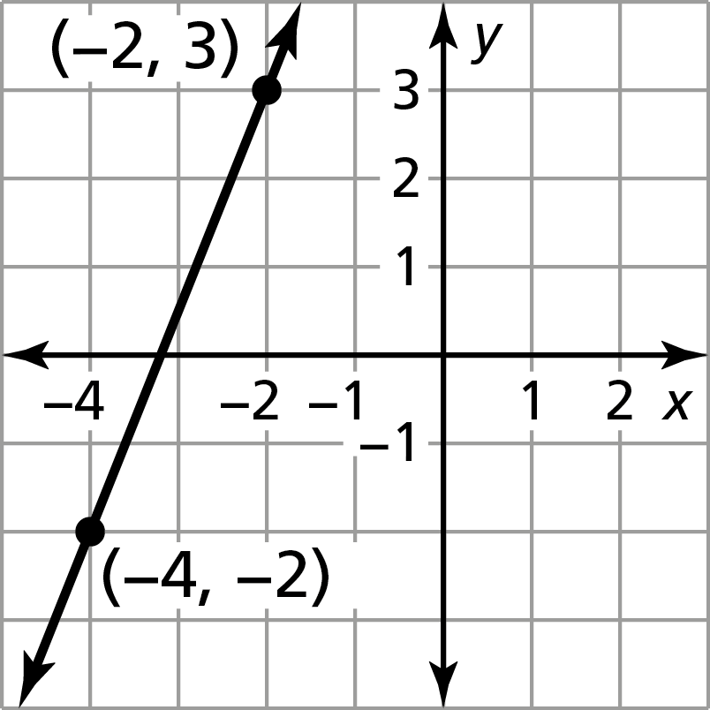

7. (1, 4), (3, 2) 8. (1, 2), (1, 2)

9.

|  |  |  |  |  |
| --- | --- | --- | --- | --- |
| *x* | −5 | −3 | 3 | 3 |
| *y* | 15 | 7 | −17 | −25 |

|  |  |  |  |  |  |  |  |  |  |  |  |  |  |  |  |  |  |
| --- | --- | --- | --- | --- | --- | --- | --- | --- | --- | --- | --- | --- | --- | --- | --- | --- | --- |
| I | T | M | S | A | O | N | H | A | P | L | R | O | M | E | L | S | L |
| 2 | $$\frac{2}{5}$$ | 0 |  |  |  | 3 | $$\frac{1}{4}$$ | $$\frac{3}{2}$$ | $$\frac{1}{50}$$ | 1 | −4 | $$\frac{5}{2}$$ | $$-\frac{1}{3}$$ | 2 | $$-\frac{5}{2}$$ | 5 | und. |