Name_____________________

Due Date__________________

Hour______________________

Unit 0 Exam Prep



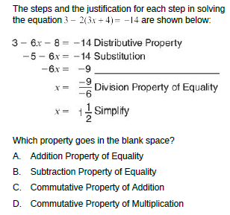

2.

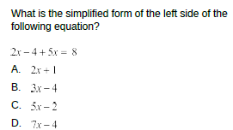

3.

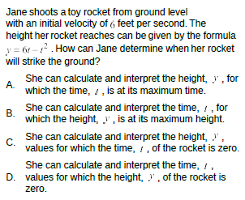

4.

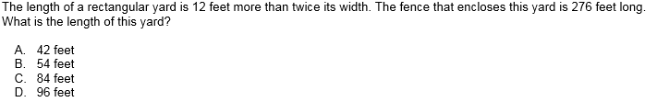

5.

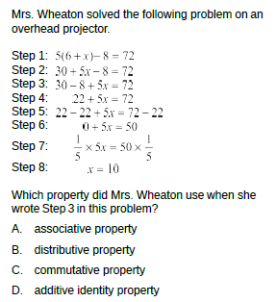

6.

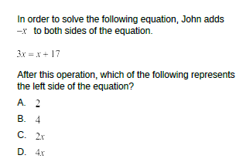

7.

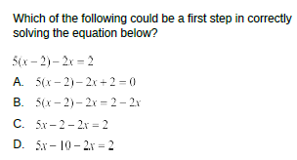

8.

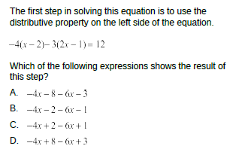

9.

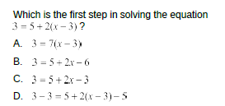

10.

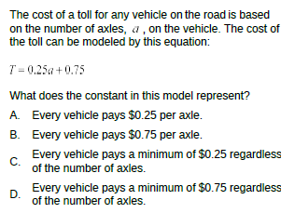

11.

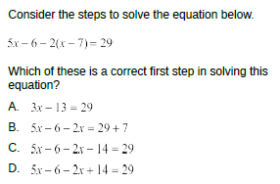

12.

