Name_____________________

Due Date__________________

Hour______________________

Unit 1A Exam Prep

1.

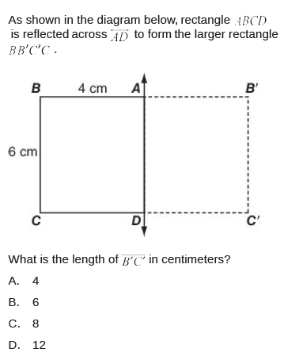

2.

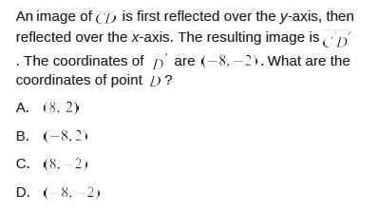

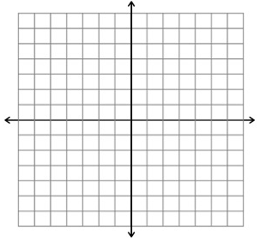

3.

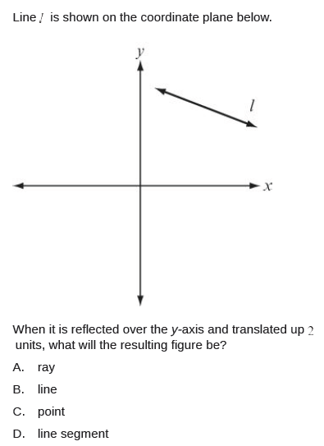

4.

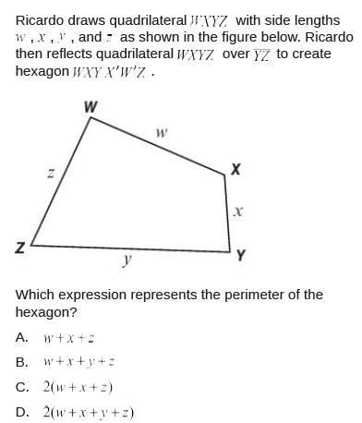

5.

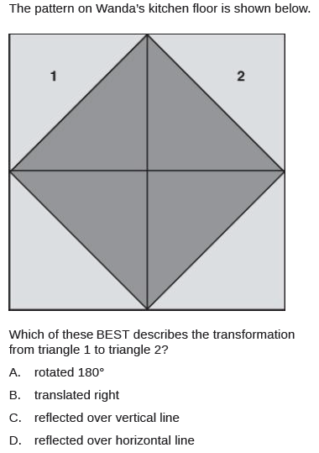

6.

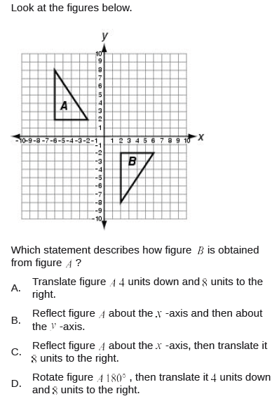

7.

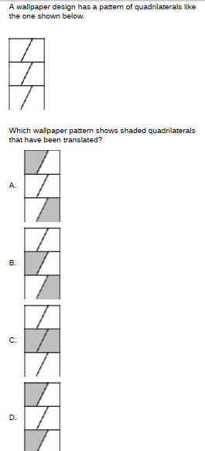

8.

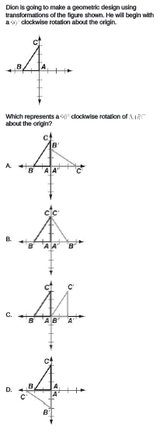

9.

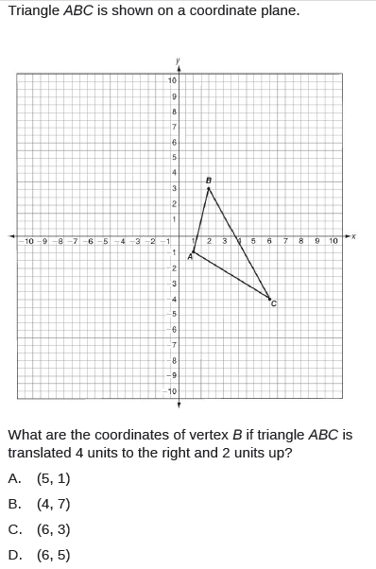

10.

