Name_____________________
Due Date__________________
Hour______________________
Unit 1B Review
1.
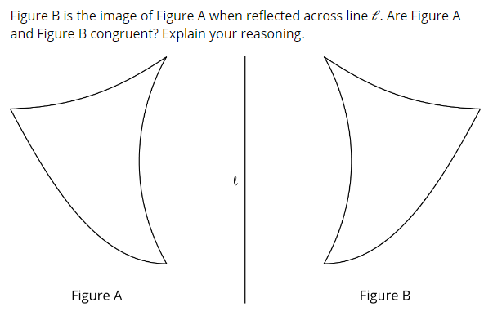
2.
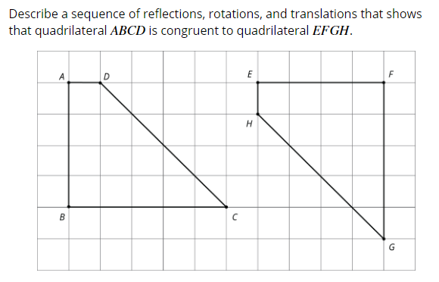

3.
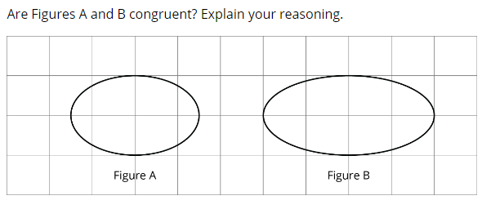
4.
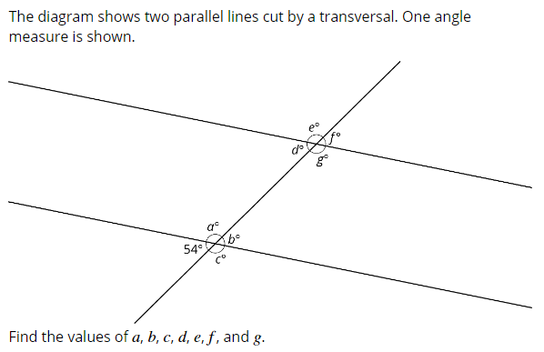
5.
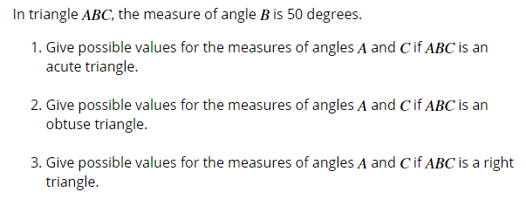
6.
- In an equilateral triangle, all side lengths are equal and all angle measures are equal. What are the measures of its angles?
- In an isosceles triangle, which is not equilateral, two side lengths are equal and two angle measures are equal. What are the measures of its angles?

