Name_____________________

Due Date__________________

Hour______________________

Unit 1 Review

Match the function with the correct table.

1. _____ y = x
2. _____ y = x2
3. _____ y = |x|
4. _____ y =
5. _____ y = ax











Match the function with the correct graph

1. _____ y = 2x + 1
2. _____ y = 2x2 - 5
3. _____ y = -4|x| - 3
4. _____ y = $\frac{1}{x}$
5. _____ y = 3x

A.

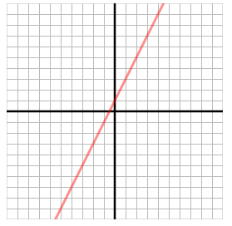

**B.**

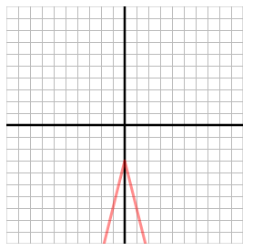

**C.**

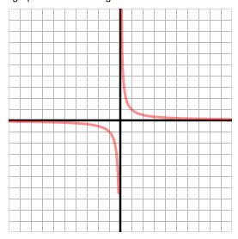

**D.**

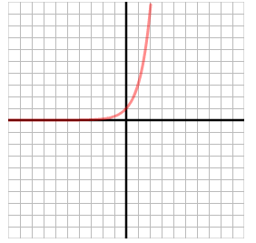

**E.**

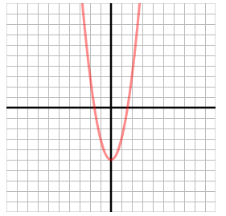

Match the time graph with the correct situation.

1. ______

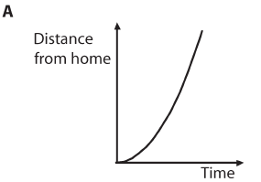

1. _____

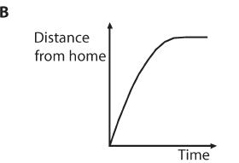

1. _____

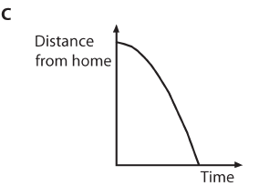

1. _____

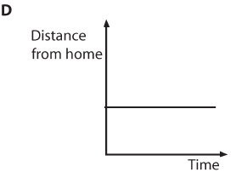

A.

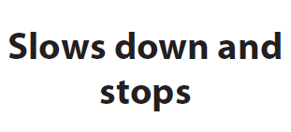

B.

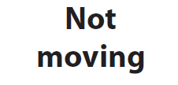

C.

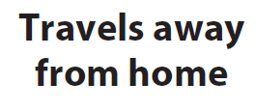

D.



1. Model the function rule y = 9 – x2 with a table and a graph.

|  |  |  |
| --- | --- | --- |
| x | y = 9 – x2 | (x, y) |
| 3 |  |  |
| 1 |  |  |
| 0 |  |  |
| -3 |  |  |

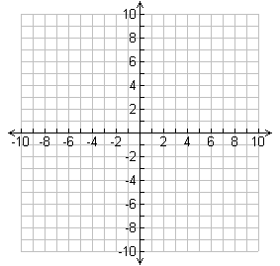

1. Find the domain and range of the relation.





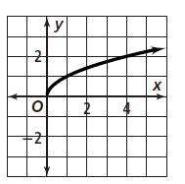

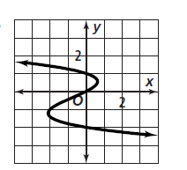



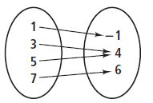

20.

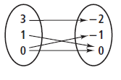



21.



Find the domain and range for each graph.

22.

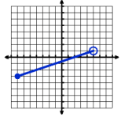

23.

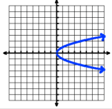

24.

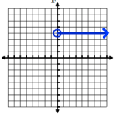

Write a function rule for the table.

25.

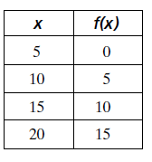

26.



