Name_____________________

Due Date__________________

Hour______________________

Unit 2 Exam Prep



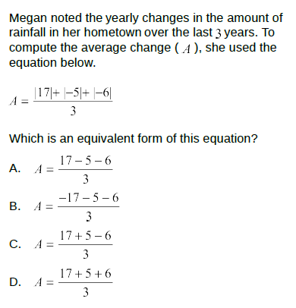

2.

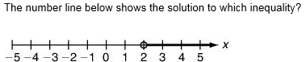

1. 3x – 5 < 1
2. 5 – 3x > 1
3. 3x + 7 > 1
4. 7 - 3x < 1

3.

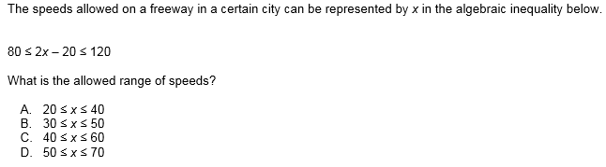

4.

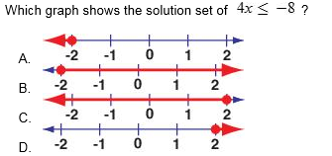

5.

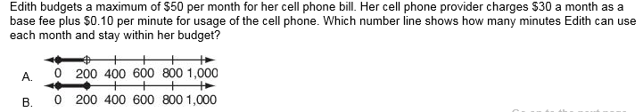

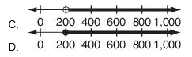

6.



1. 4.50x ≤ 25
2. 4.50x ≥ 25
3. 4.50x = 25
4. 25 ÷ 4.50

7.

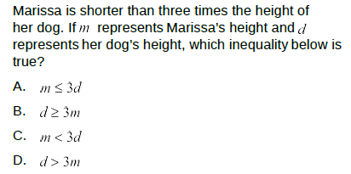

8.

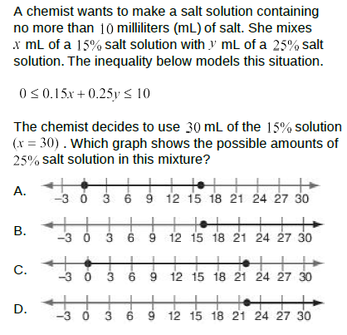

9.

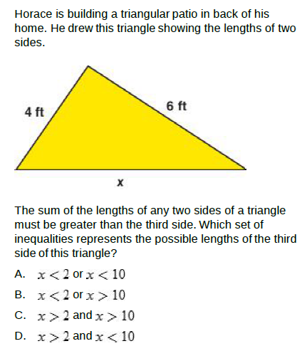

10.

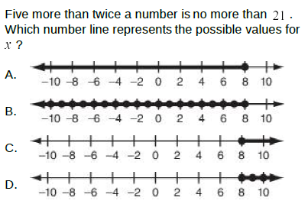

11.

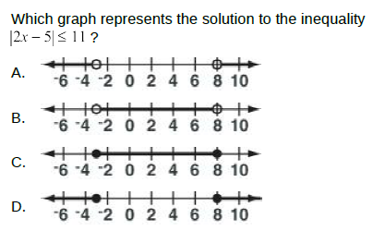

12.

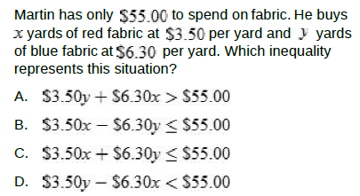

13.

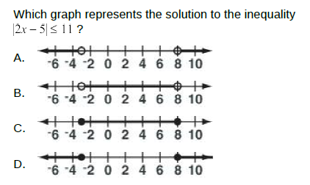

14.

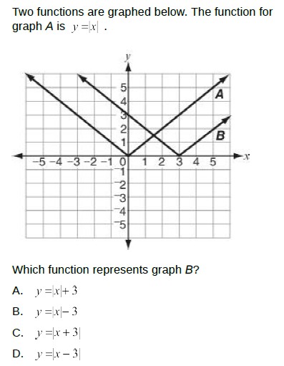

15.

