Name________________________
Due Date_____________________
Hour_________________________
Unit 2 Review
Solve each inequality and graph the solution.
- 3x – 8 ≥ -2x + 22

- 2(3b -2) < 4b + 8

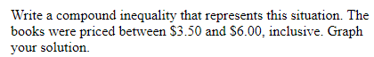

4.
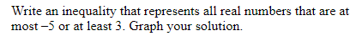

Solve each compound inequality and graph the solution.
5. x -2 ≥ -6 and 5 + x < 7

6. -3 < x – 5 or x + 5 ≤ 2

Solve each equation. If there is no solution, write “no solution”.
7. |x + 3|- 2 = 4

8. |b| = -2
Solve each inequality. Graph the solution.
9. |x - 3| ≥ 5

10. |x| - 5 < 3

Graph each absolute value equation by translating.
11. |x -2| = y

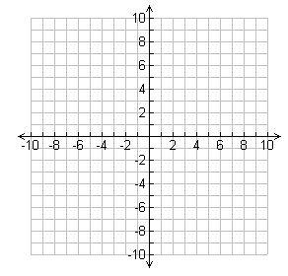
12. y = |x| + 4
13. y = -|x -4| + 2
14. Write an equation for the translation left 7 units of y = |x|.

15. Write an equation for the translation up 6 units of y = -|x|

16. Write an equation for the translation up 2 units, right 1 unit of y = |x|.

Graph each inequality and write the solution. Tell if it is a conjunction or disjunction.
17. |w + 2| ≥ 5
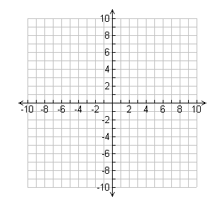
18. |y - 5|< 2
19. Beatriz is in charge of setting up a banquet hall. She has five tables that will seat six people each. If no more than 62 people will attend, how many tables seating four people each will she need? Write and solve an inequality to solve.

20. The crowd that heard the President speak was estimated to be 10,000 people. The actual crowd could be 750 people more or less than this. What are the possible values for the actual crowd size? Write and solve a compound inequality.

21. The average number of cucumber seeds in a package is 25. The number of seeds in the package can vary by three. Find the range of acceptable numbers of seeds in each package. Write and solve an absolute value inequality.

20.

