Name _______________________________________ Date ___________________

1. Triangle GHJ has coordinates G(-10, 6), H(2, 6), J(2, -3). It is dilated by a scale factor of 3 with point J(2, -3) as the center of the dilation creating triangle G’H’J’.

What is the measure, in units, of side H’J’?

2. Square ABCD with side length of 6 units is reflected over the x-axis and then dilated by a scale factor of 5 centered at the origin.

Enter the length, in units, of side A’B’.

3. Triangle ABC is shown. The triangle is translated down 3 units and left 2 units. Enter the length of A’C’, in units.

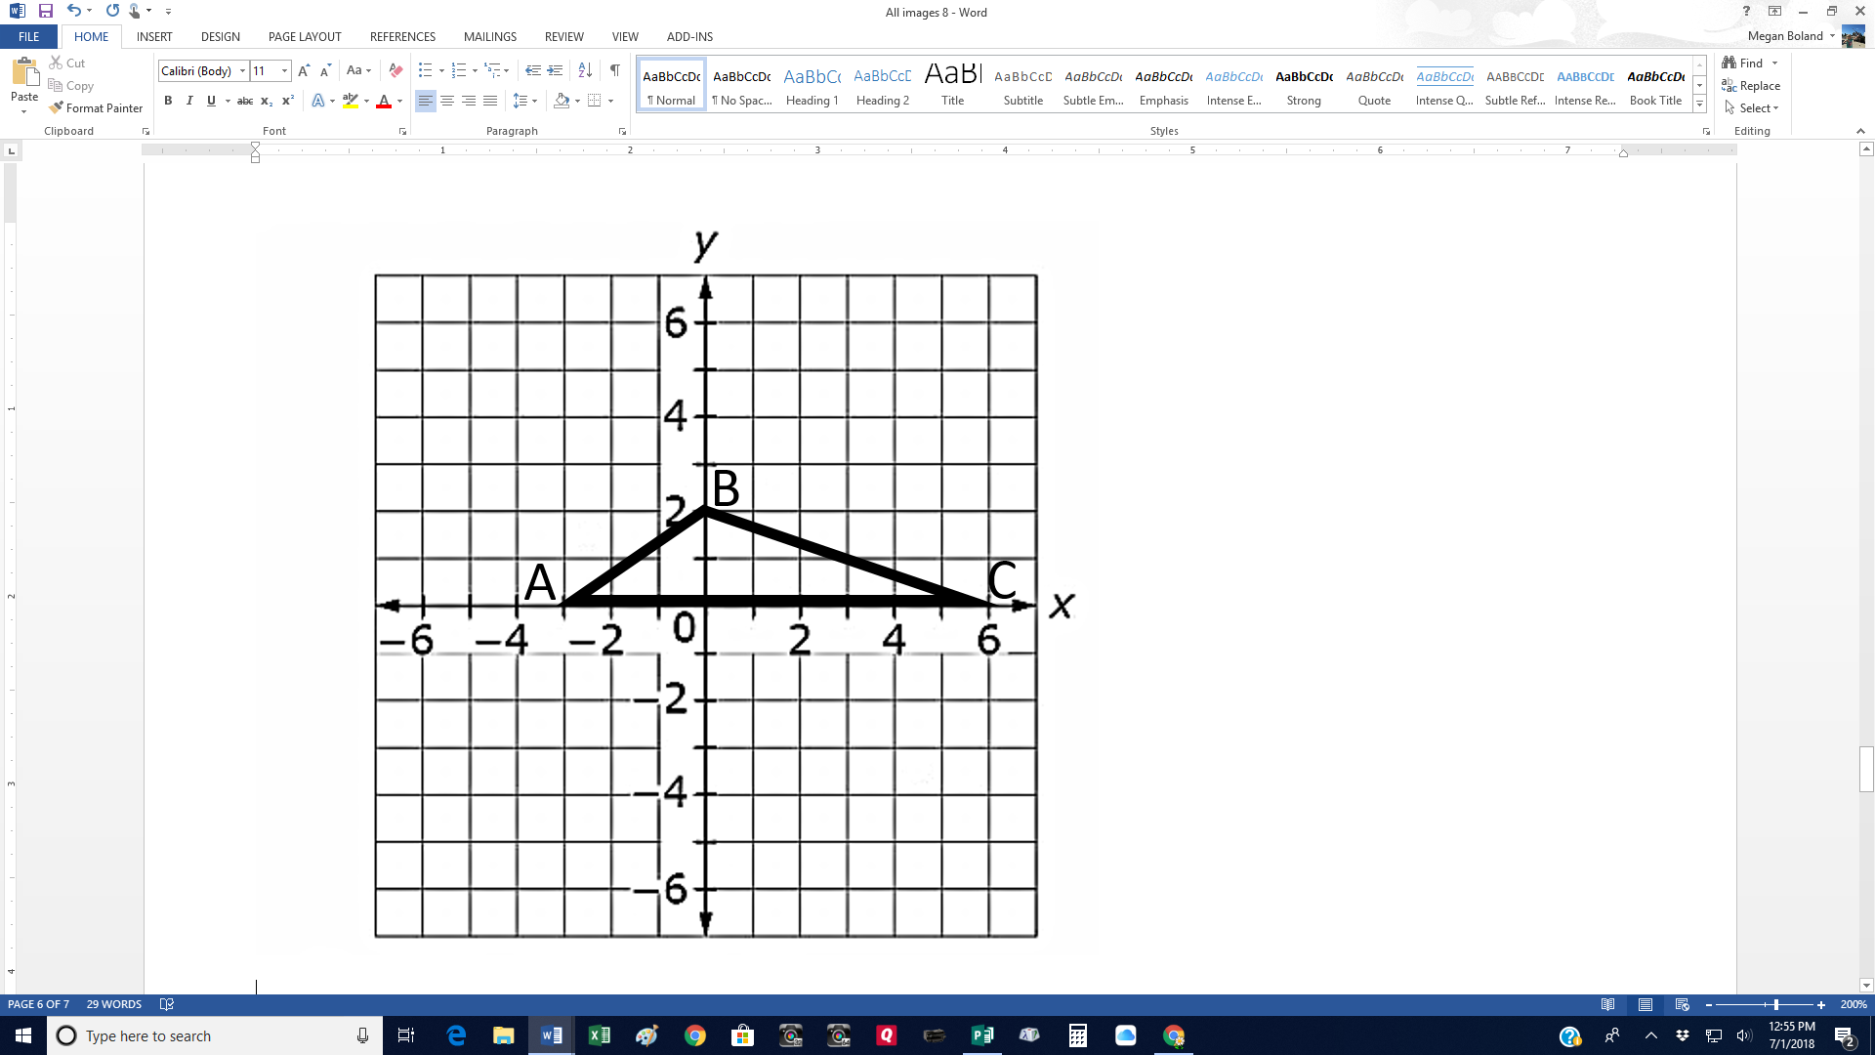

4. The figure shown is dilated by a scale factor of $\frac{1}{2}$ with (0, 2) as the center of the dilation. Enter the length of C’D’, in units.

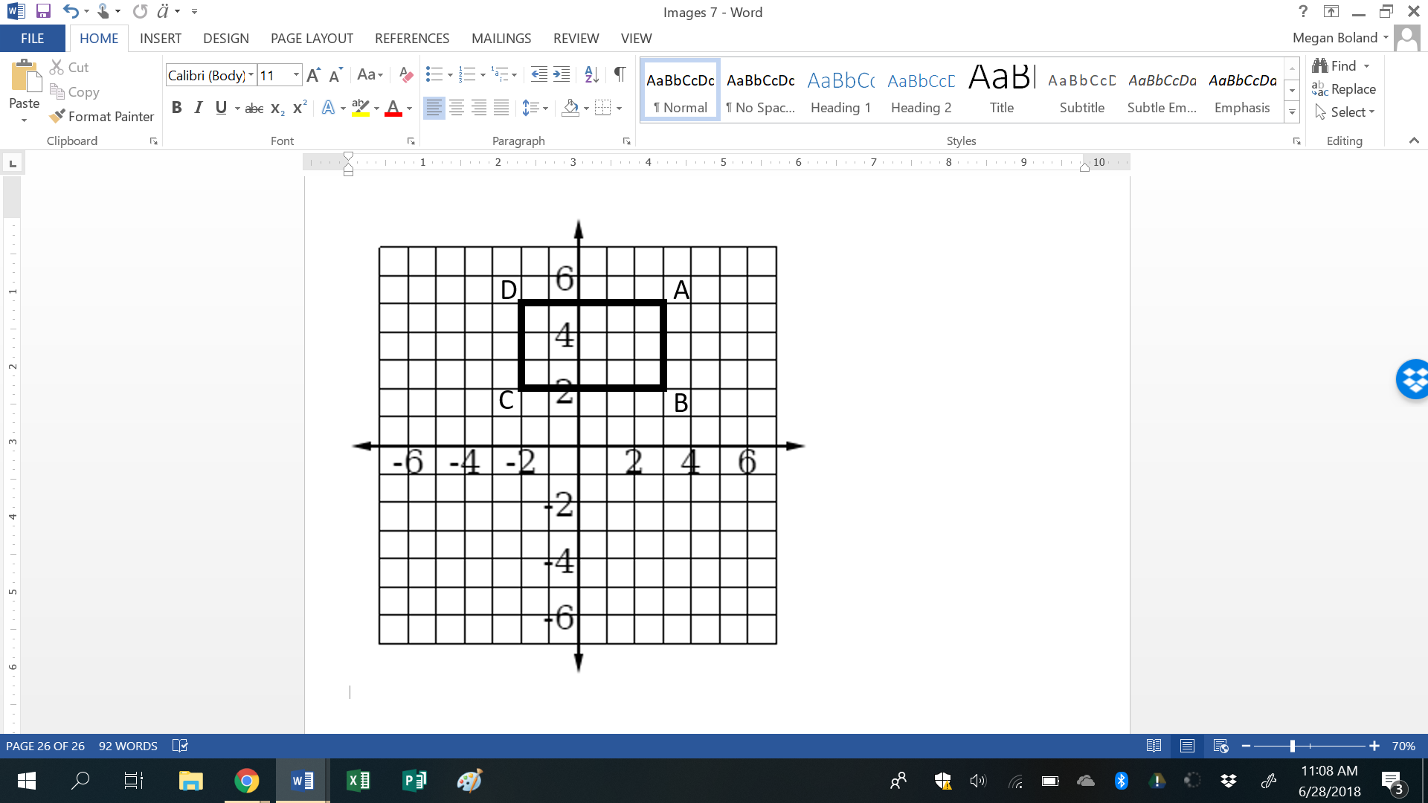

Name _______________________________________ Date ___________________

5. Line segment DE has endpoints D(-3, 2) and E(-3, -3). DE is dilated with (-3, 0) as the center and a scale factor of 1.5 units. Draw the D’E’ on the second grid.

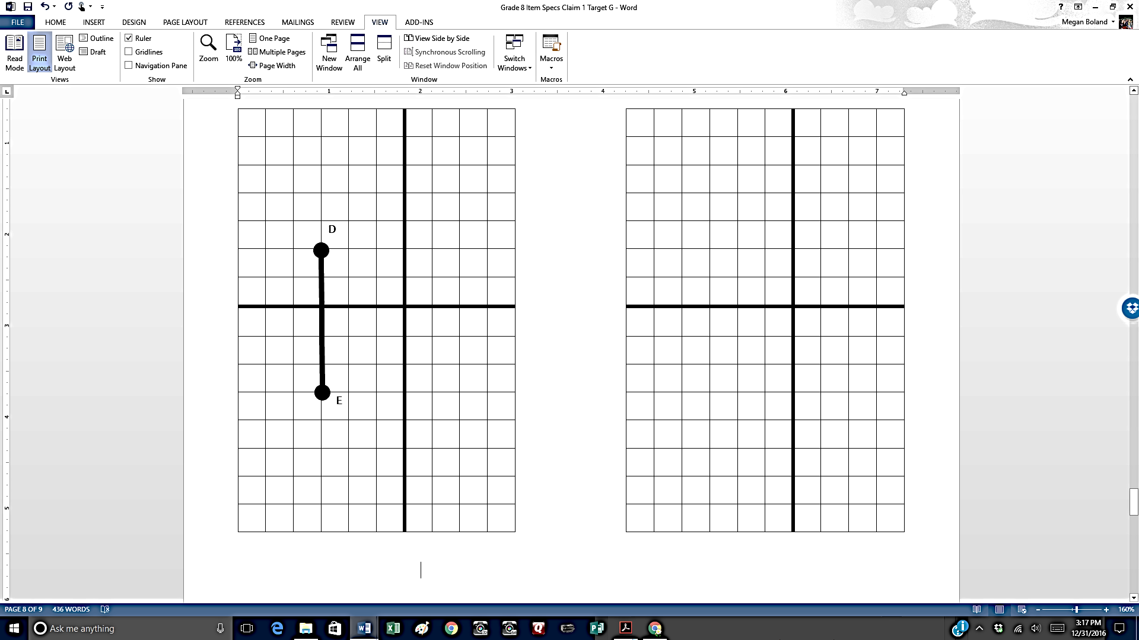

6. The figure ABCDE is dilated by 200% centered at the origin. Use the connect line tool to draw the to draw the resulting image of the figure.

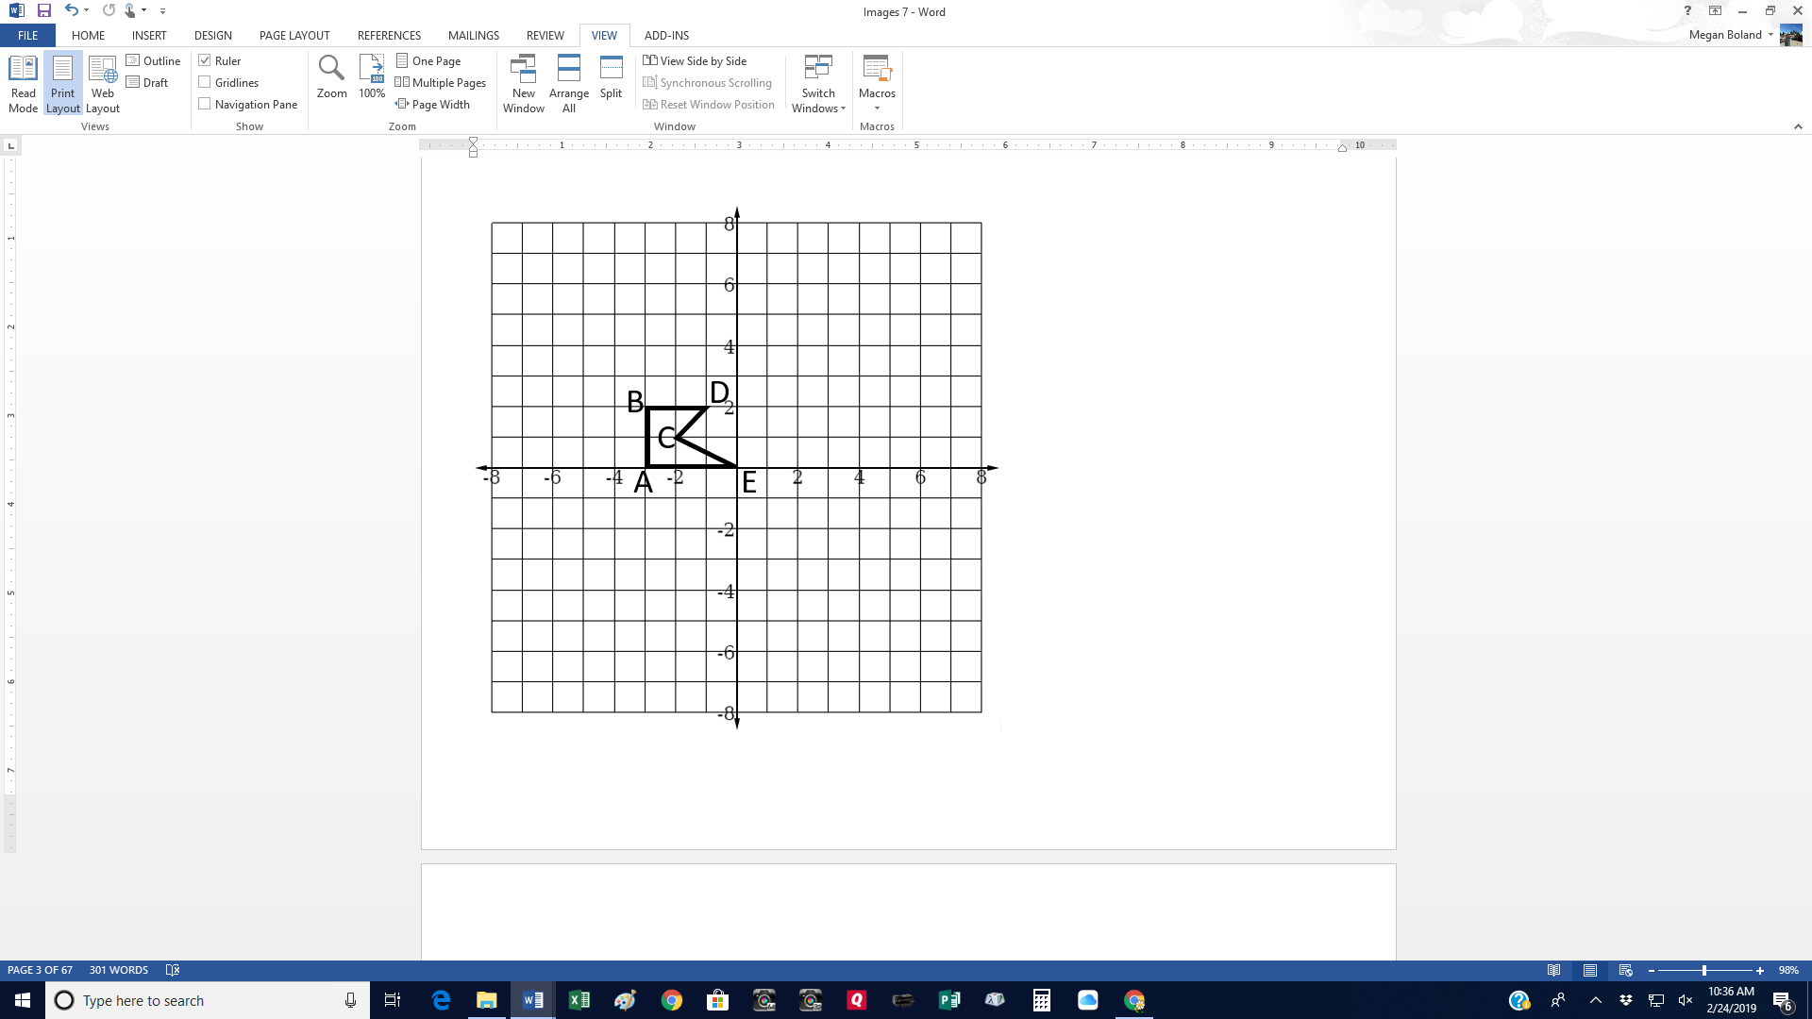

Name _______________________________________ Date ___________________

7. Triangle ABC is shown on this coordinate grid.

The coordinates are A(2, 2), B(2, 6), and C(7, 3).

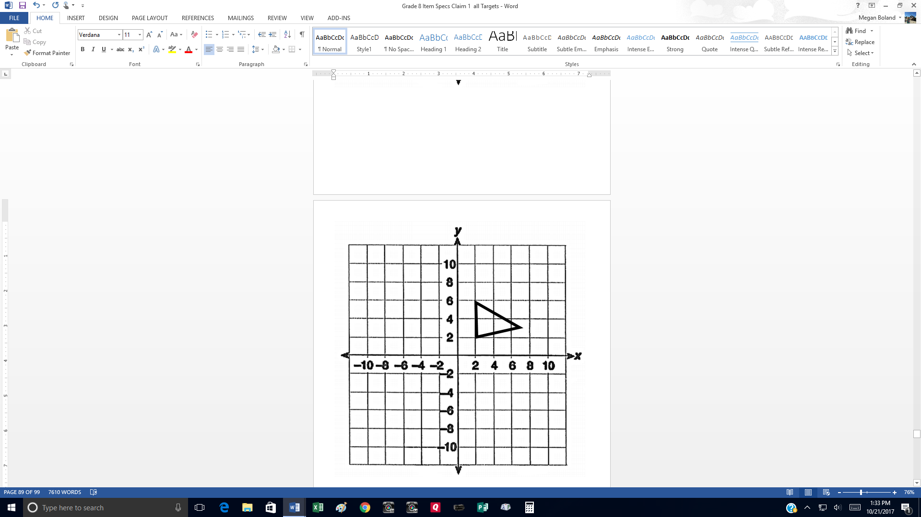

Triangle ABC is dilated with the origin as the center of the dilation. Which ordered pair could represent the image of point C(7, 3) after the dilation?

A. (6, 2)

B. (9, 9)

C. (-10.5, -4.5)

D. (3.5, -0.5)

8. The triangle on the grid is translated 2 units down and 5 units left. Next a dilation centered at the origin is applied with a scale factor of 4. What are the coordinates of A’?

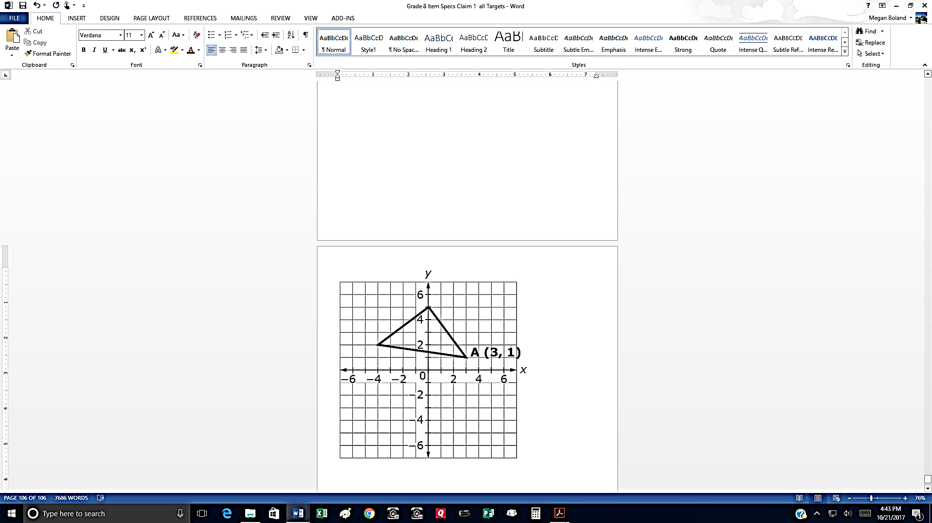

Name _______________________________________ Date ___________________

9. Triangles are shown. (Not drawn to scale.) Enter the value of x and y.

x =

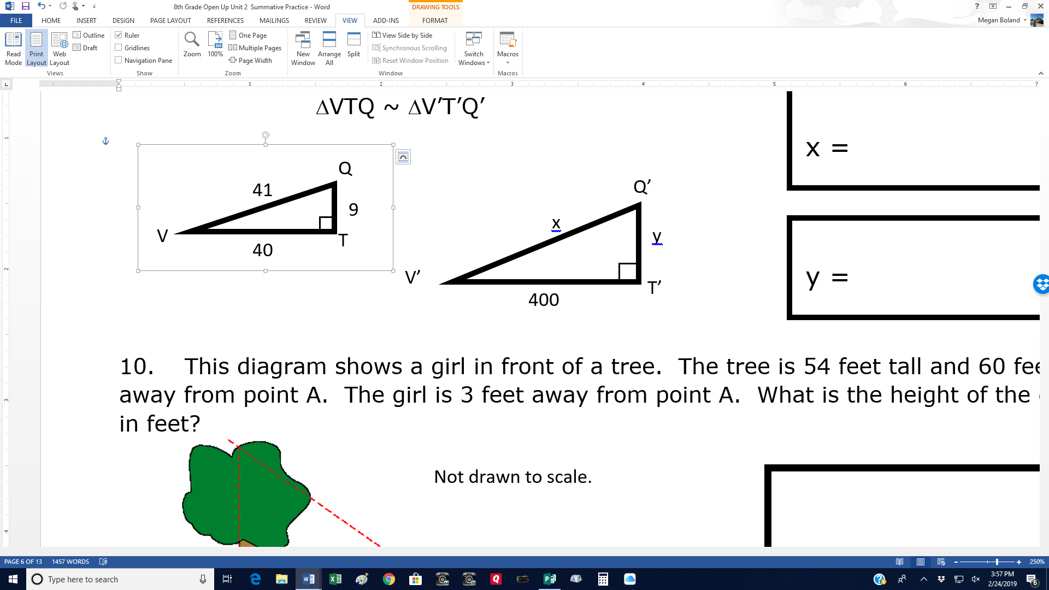ΔVTQ ~ ΔV’T’Q’

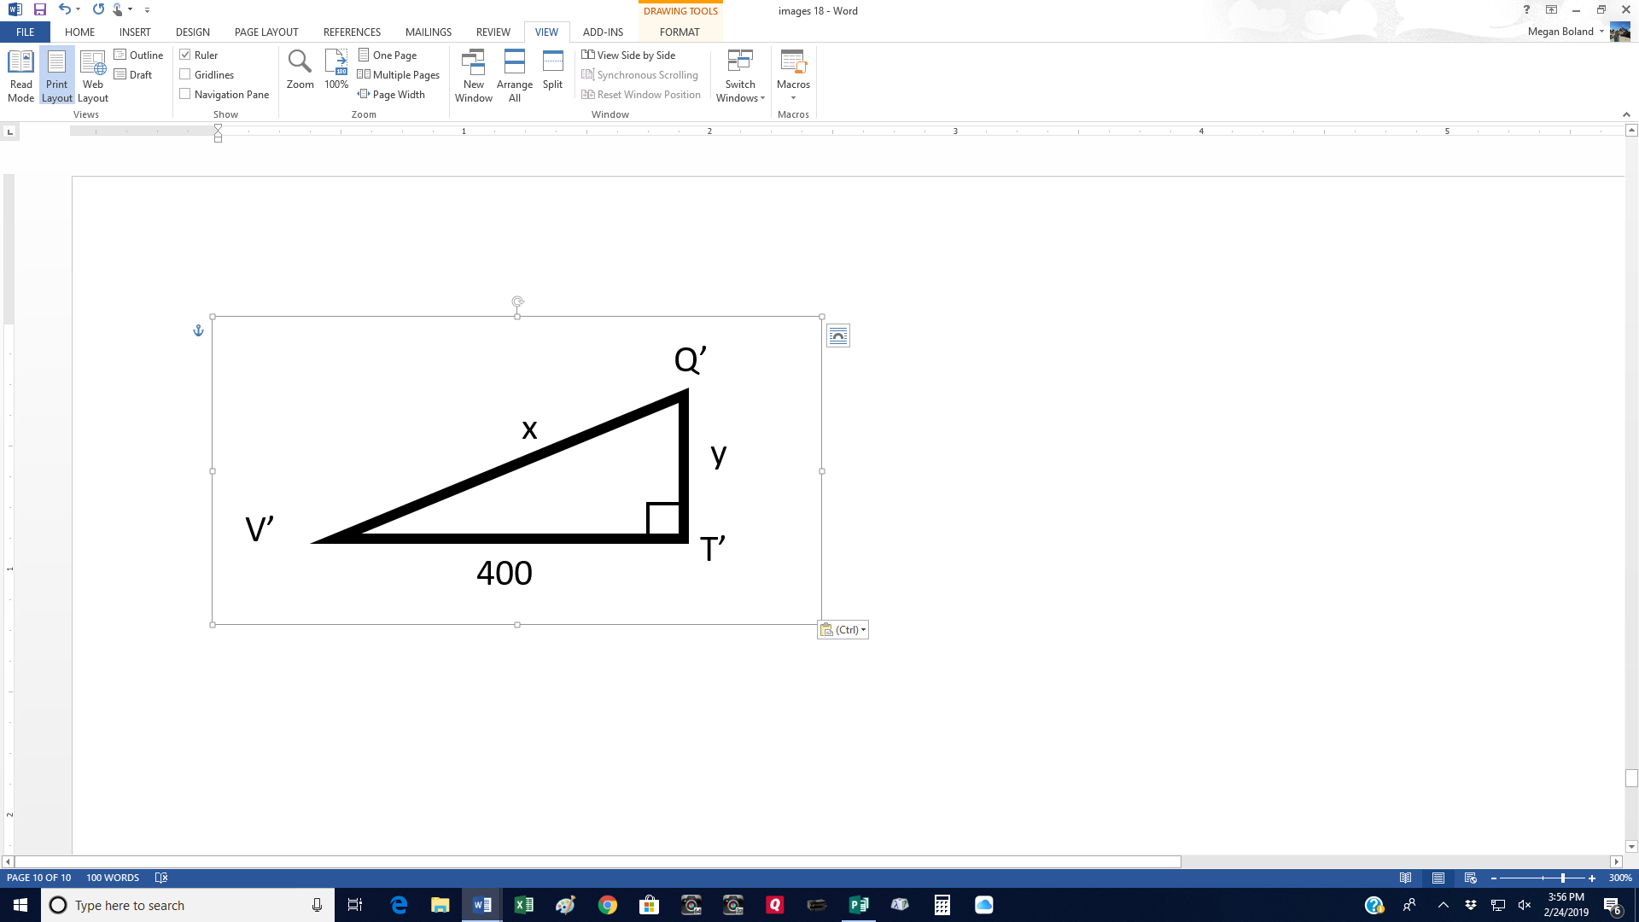

y =

10. This diagram shows a girl in front of a tree. The tree is 54 feet tall and 60 feet away from point A. The girl is 3 feet away from point A. What is the height of the girl in feet?

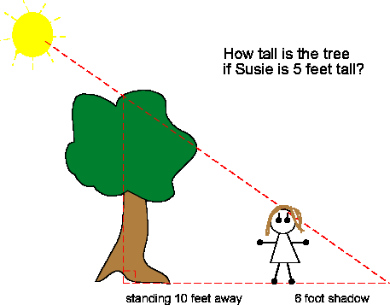

Not drawn to scale.

**A**

54 feet

11. Right triangle EFG is shown. (Not drawn to scale.) Enter the value of x and y.

ΔEFG ~ ΔE’F’G’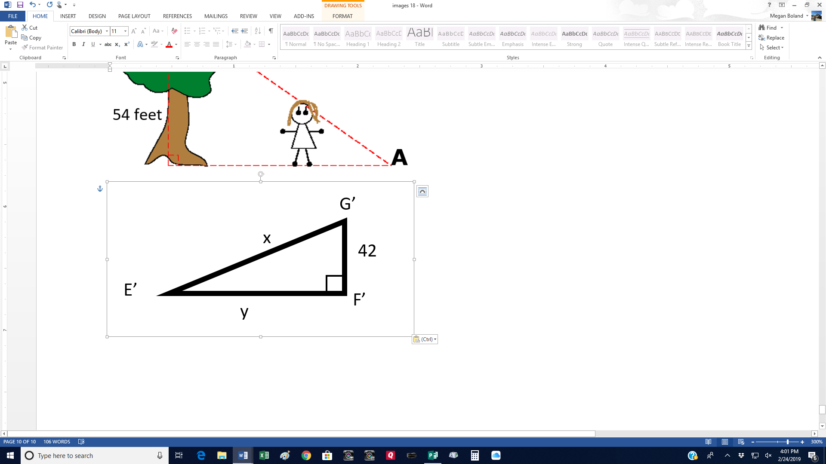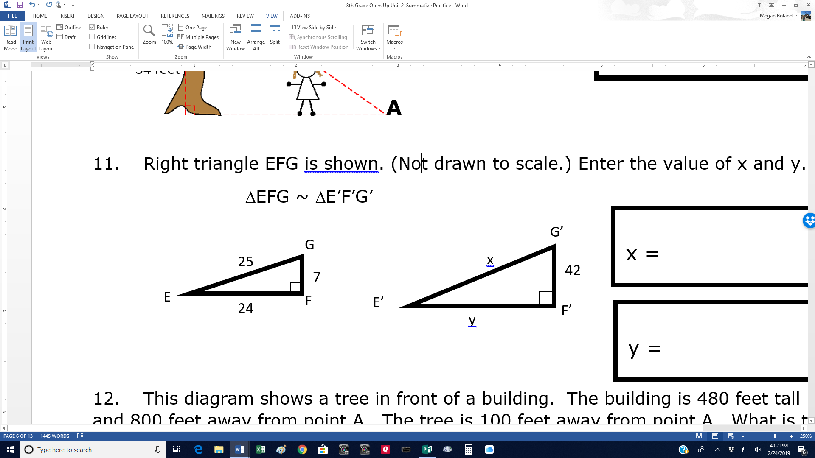

x =

y =

12. This diagram shows a tree in front of a building. The building is 480 feet tall and 800 feet away from point A. The tree is 100 feet away from point A. What is the height of the tree in feet?

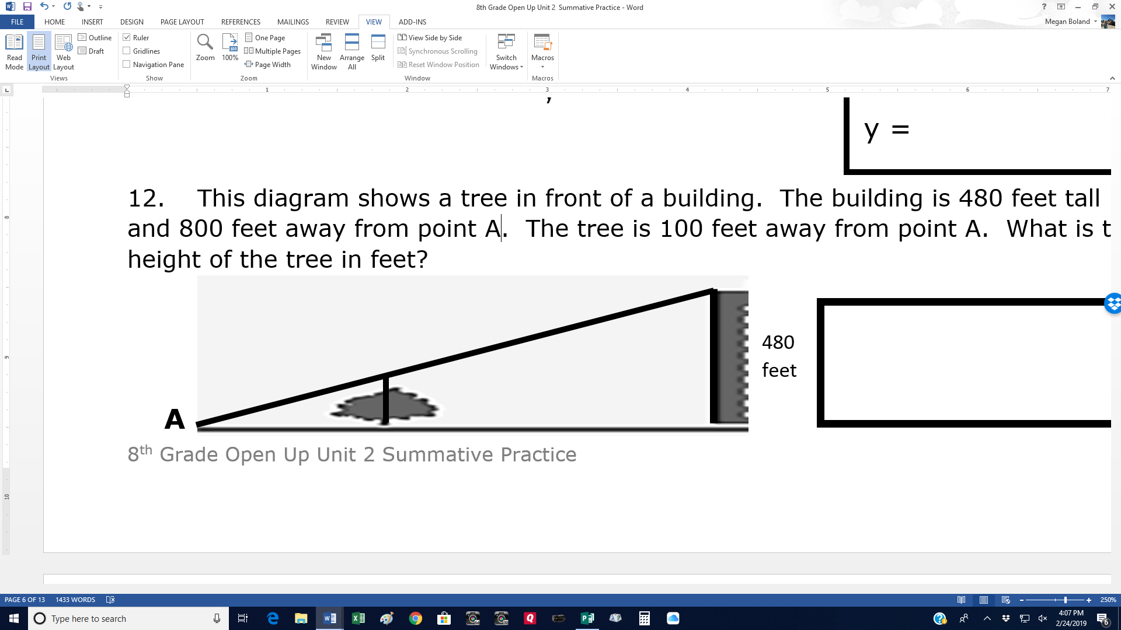

Name _______________________________________ Date ___________________

13. Figure A is a scale image of Figure B, as shown. The scale that maps Figure A onto Figure B is $1:3\frac{1}{2}$. Enter the value of x.



14. A drawing of a house is 8.5 inches tall. Enter the height of the house, in feet.

Scale: 2 in to 5 ft



8.5 inches

? feet

Name _______________________________________ Date ___________________

15. Figure B is a scale image of Figure A, as shown. Enter the scale factor applied to Figure A to produce Figure B.



16. A large rocket is 100 cm long. A small rocket is 20 cm long. Enter the scale factor applied to the small rocket to produce the large rocket.

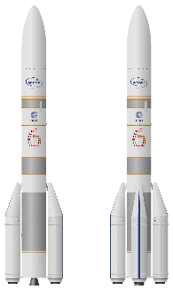

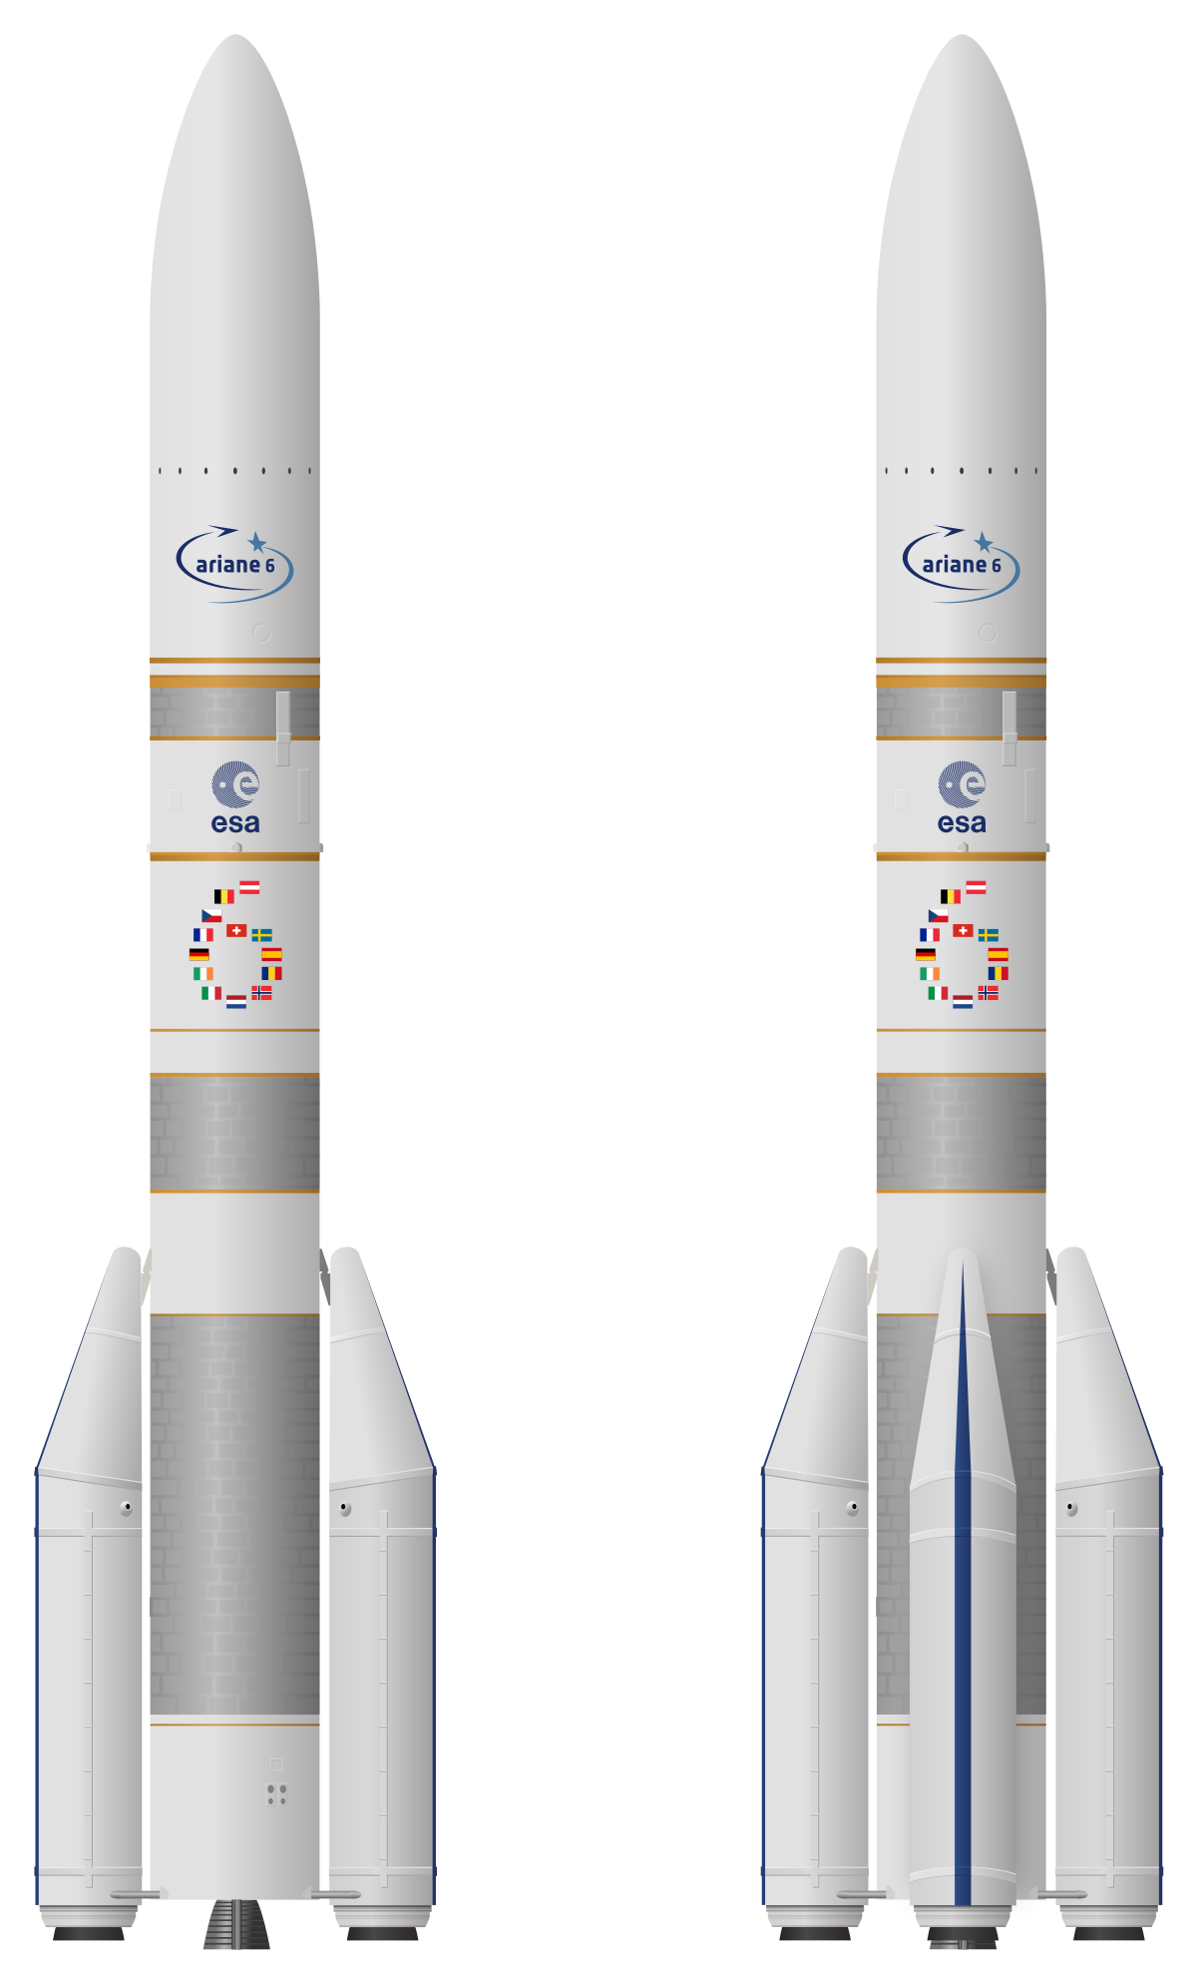

17. Consider this picture an artist painted of a doll house. The height of the picture of the dollhouse is 6.8 inches. The height of the actual dollhouse is 102 inches. Enter the scale factor applied to the picture to obtain the height of the actual dollhouse.

.

Name _______________________________________ Date ___________________

18. The triangle ABC is drawn. Then a dilation is applied with the center of dilation at the origin. The position of A is (0, 2) and the position A’ is (0, 6).

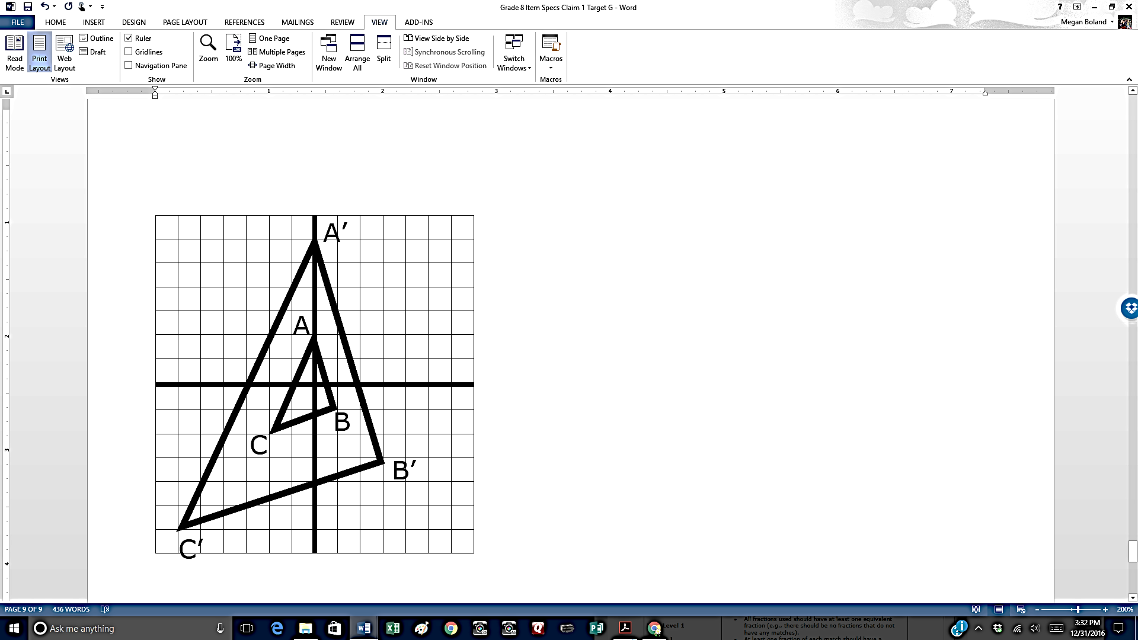

Which of the following is the scale factor?

A. 6

B. 5

C. 4

D. 3

19. Figure ABCD is drawn. Then a dilation is applied with the center of dilation at the (1, 0) to create A’B’C’D’.

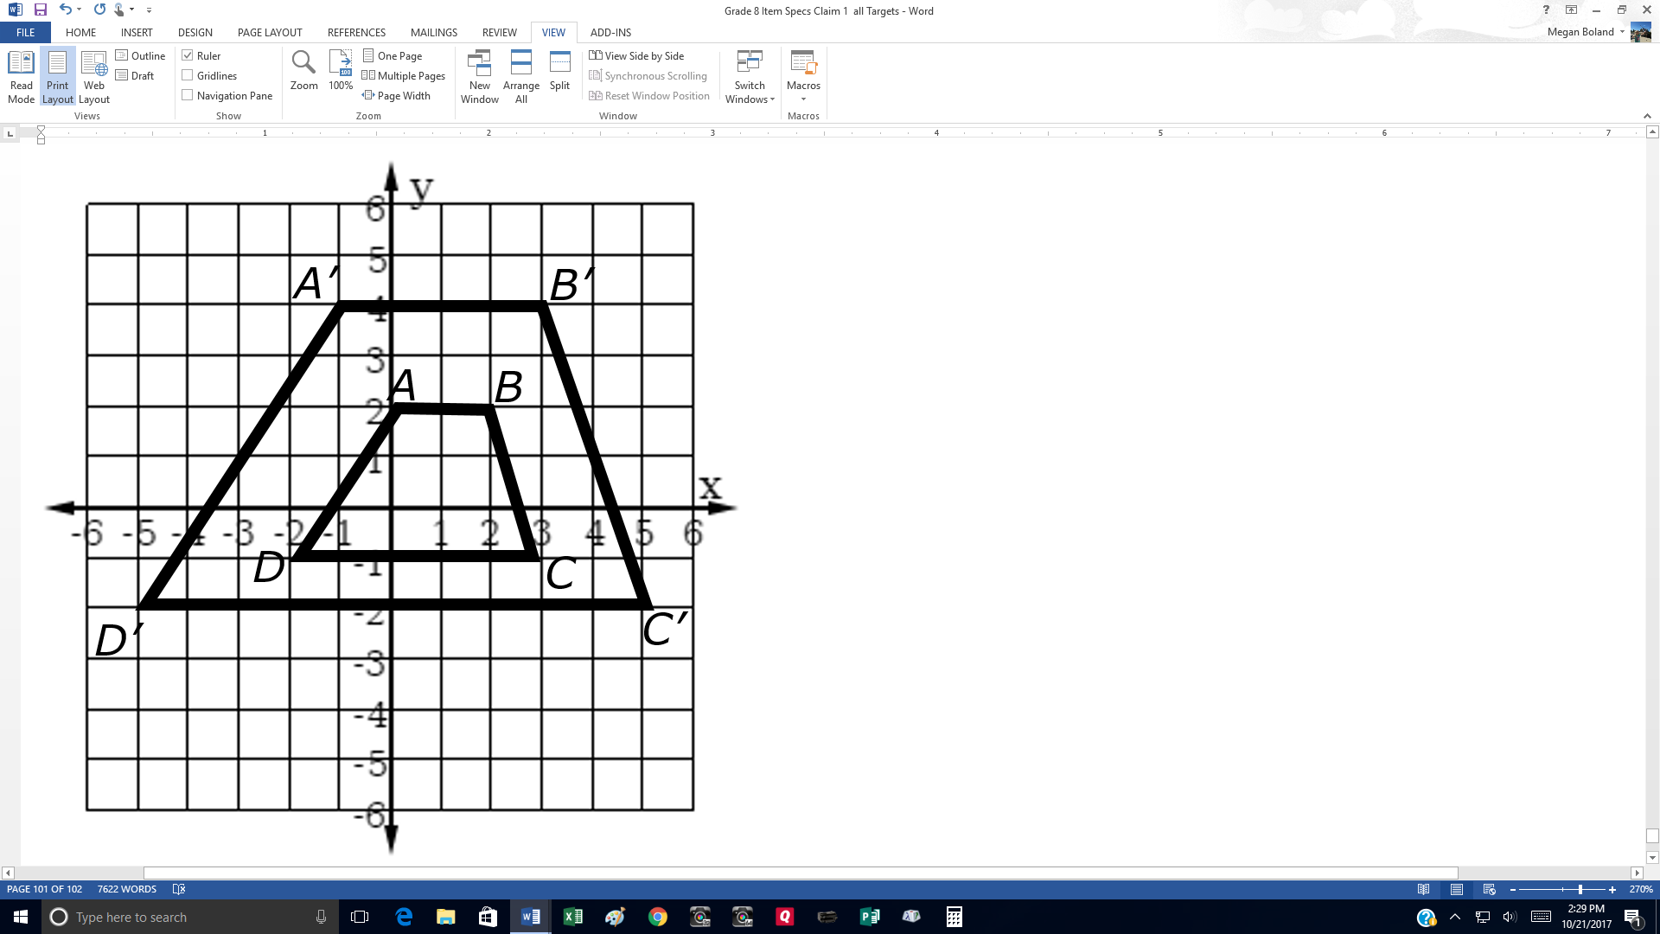

Which of the following is the scale factor?

A. 1

B. 2

C. 3

D. 4

Name _______________________________________ Date ___________________

20. Consider this diagram. The position of B is (6, -3) and the position B’ is (2, -1).

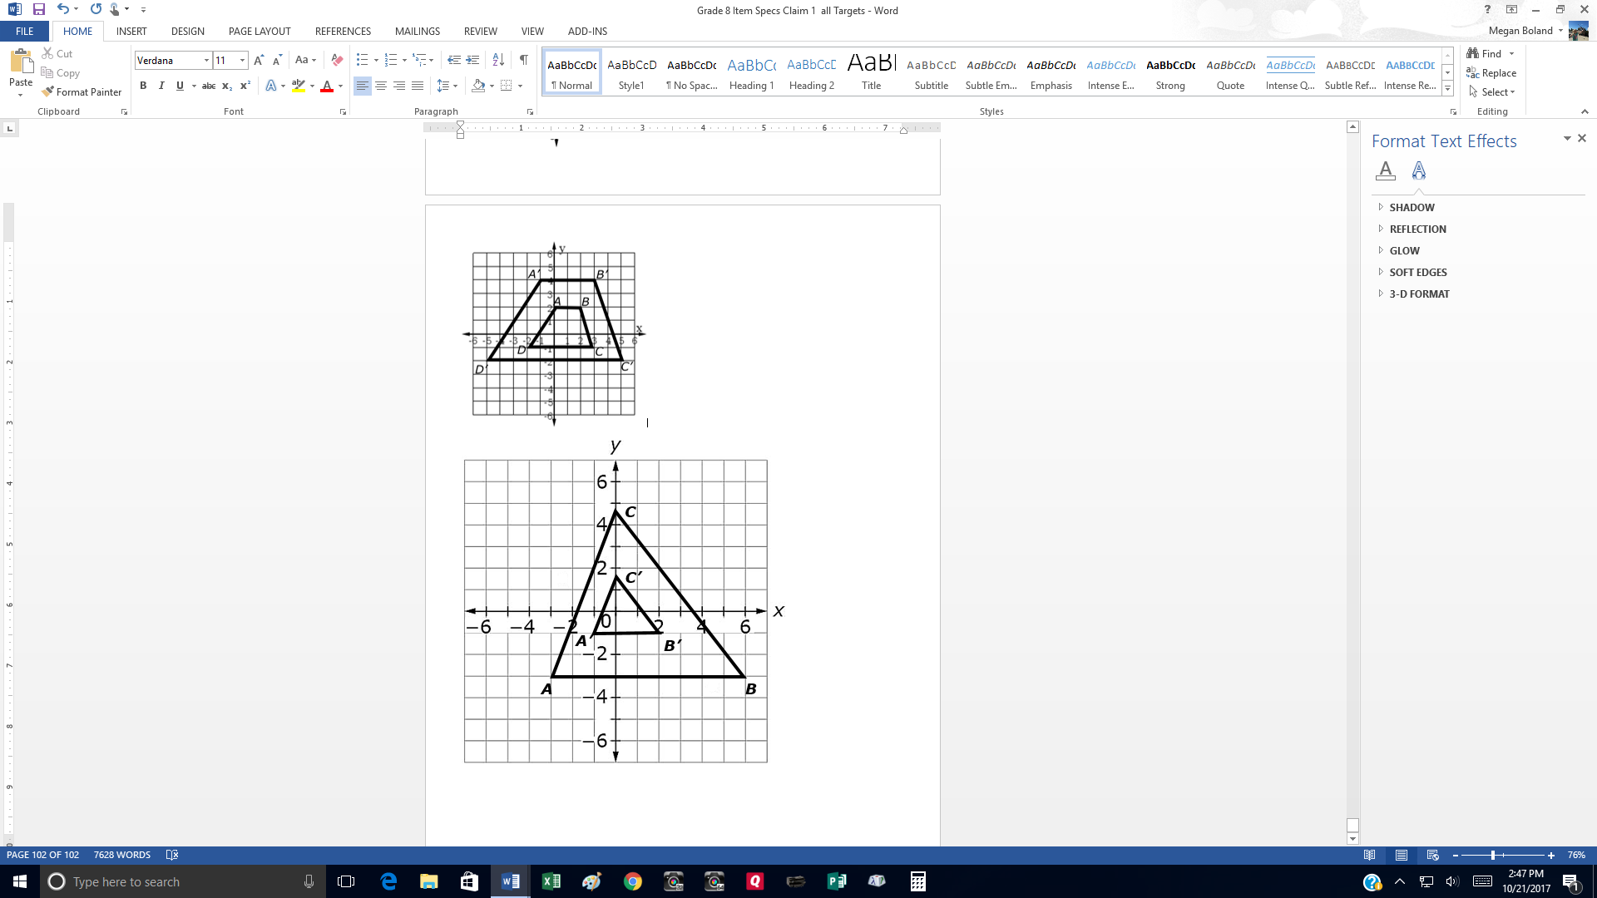

Consider the statements in the table shown. Select True or False for each statement.

|  |  |  |
| --- | --- | --- |
| Statement | True | False |
| The scale factor of the dilation cannot be calculated. |  |  |
| The length of A’B’ is the product of AB and the scale factor. |  |  |
| The scale factor of the dilation is 3. |  |  |
| ΔABC ~ ΔA’B’C’ |  |  |

21. Consider these scalene triangles. ΔACB ~ ΔPRQ

Q

B

A

P

C

R

Consider the statements in the table shown. Select True or False for each statement.

|  |  |  |
| --- | --- | --- |
| Statement | True | False |
| $\frac{AB}{PR}= \frac{BC}{QR}$ |  |  |
| ∠P ≅ ∠A |  |  |
| $AB •PR=PQ •AC$ |  |  |