Name_____________________
Due Date__________________
Hour______________________
Unit 3 Review
- This graph represents the positions of two turtles in a race.
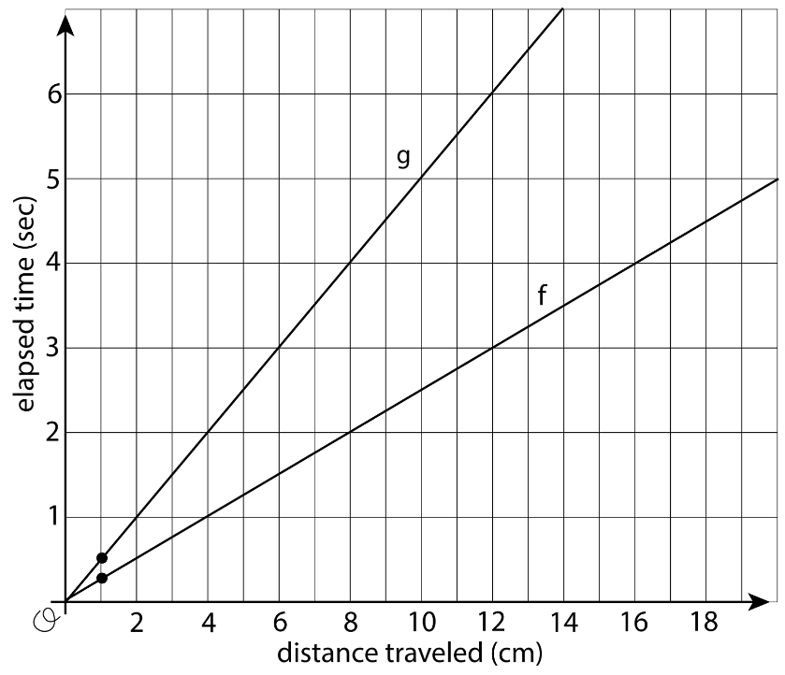
- On the same axes, draw a line for a third turtle that is going half as fast as the turtle described by line $g$.
- Explain how your line shows that the turtle is going half as fast.

2.
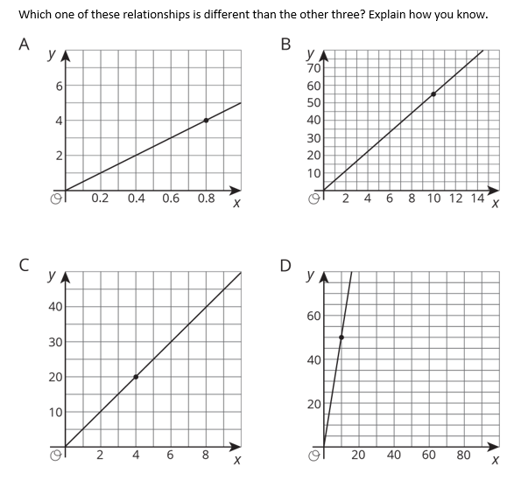

3.
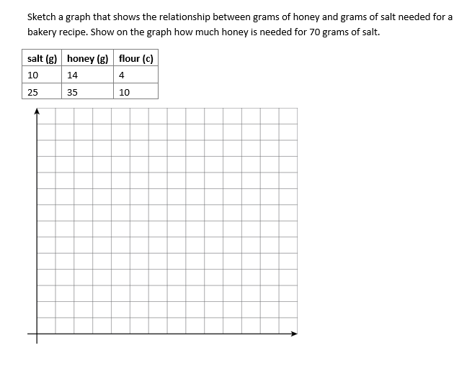
4. Here are recipes for two mixtures of salt and water that taste different.
Mixture A:
salt (teaspoons) | water (cups)
4 | 5
7 | $$8\frac{3}{4}$$
9 | $$11\frac{1}{4}$$
Mixture B is defined by the equation $y=2.5x$, where $x$ is the number of teaspoons of salt and $y$ is the number of cups of water.
- If you used 10 cups of water, which mixture would use more salt? How much more? Explain or show your reasoning.
- Which mixture tastes saltier? Explain how you know.

5. A shorter style of cup is stacked tall. The graph displays the height of the stack in centimeters for different numbers of cups. How much does each cup after the first add to the height of the stack? Explain how you know.
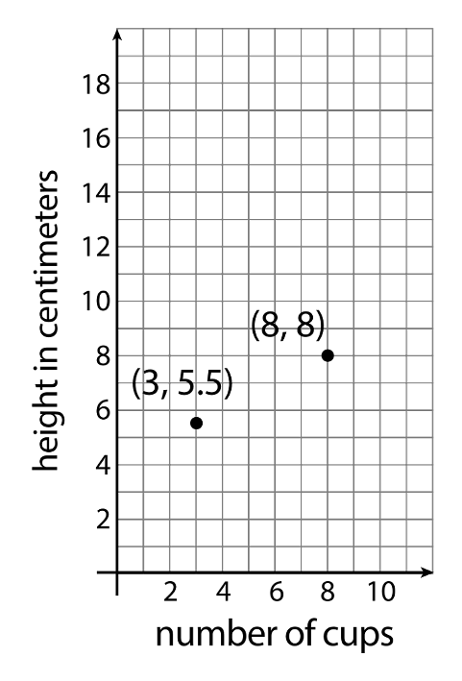
6. The graph shows the savings in Andre’s bank account.
- What is the slope of the line?
- What is the meaning of the slope in this situation?
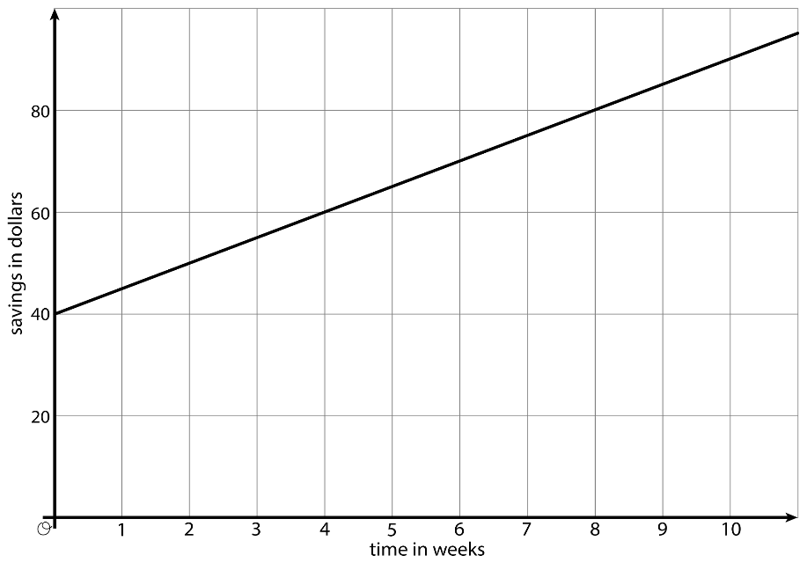

7. Make a sketch of a linear relationship with slope of 3 that is not a proportional relationship. Show how you know that the slope is 3. Write an equation for the line.
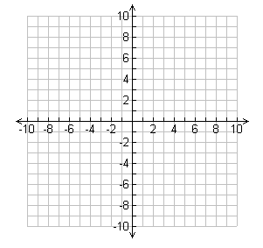
8. Describe how the graph of $y=2x$ is the same and different from the graph of $y=2x-7$. Explain or show your reasoning.

9. Each square on a grid represents 1 unit on each side.
a. Calculate the slope of graph D. Explain or show your reasoning.
b. Calculate the slope of graph E. What situation could the graph represent?
- On the blank grid, draw a line that passes through the indicated point and has slope -2.
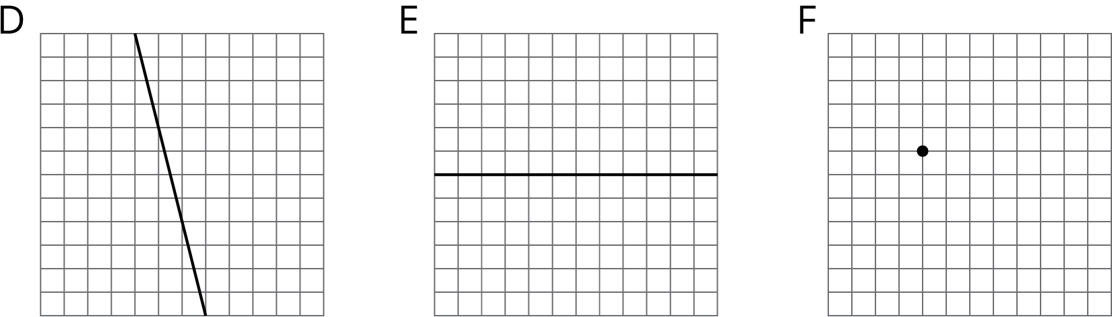
10. Without graphing, find the slope of the line that goes through
- $(0,5)$ and $(8,2)$.
- $(2,-1)$ and $(6,1)$.
- $(-3,-2)$ and $(-1,-5)$.

11. Here are 5 lines on a coordinate grid:
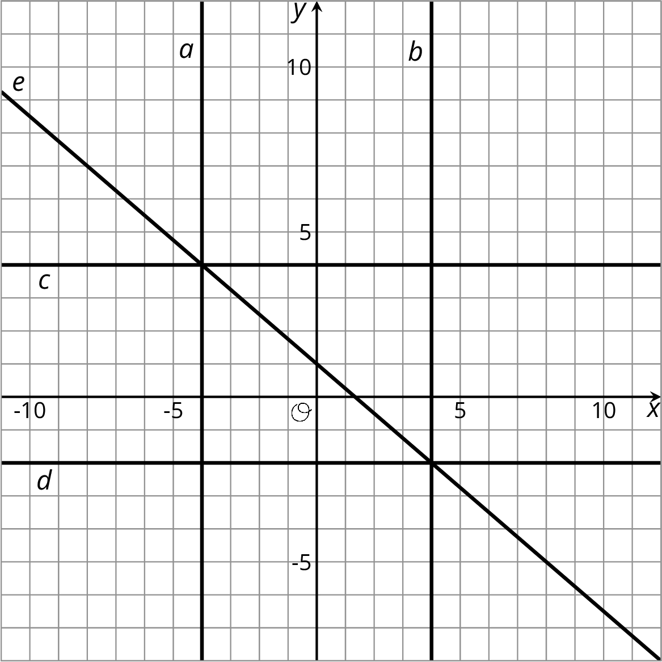
Write equations for lines $a$, $b$, $c$, $d$, and $e$.

12. Which of the following coordinate pairs make the equation $x-9y=12$ true?
- $(12,0)$
- $(0,12)$
- $(3,-1)$
- $\left(0,-\frac{4}{3}\right)$

13. A graph of a linear equation passes through $(-2,0)$ and $(0,-6)$.

- Use the two points to sketch the graph of the equation.
- Is $3x-y=-6$ an equation for this graph? Explain how you know.

