Name________________________

Due Date_____________________

Hour_________________________

Unit 2 Review

1.



2.

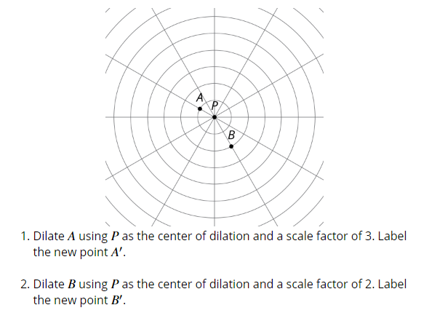

3.

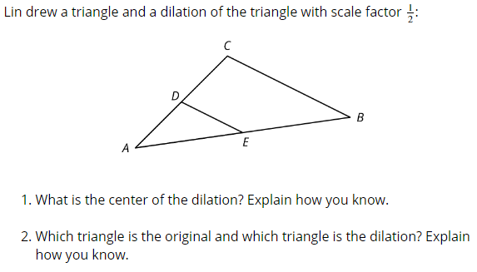

4.

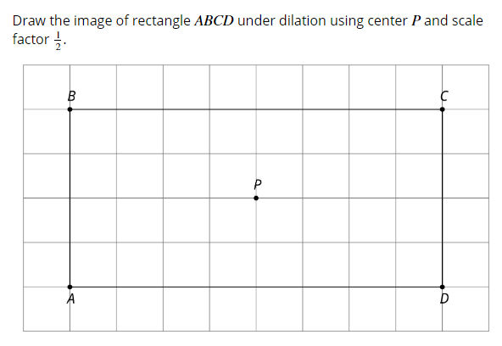

5.

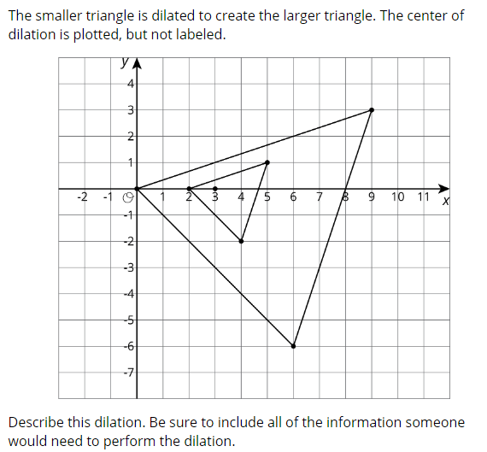

6.

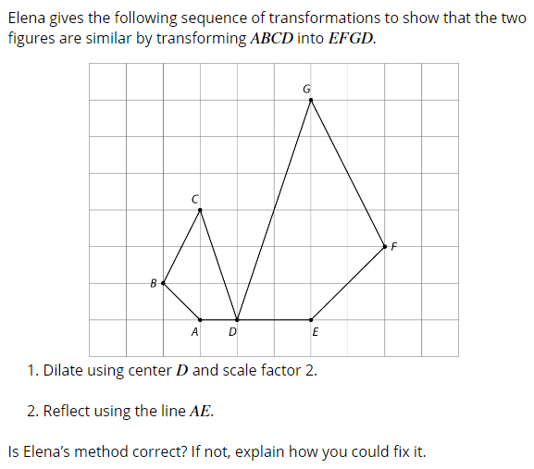

7.

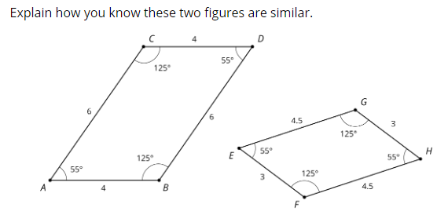

8.

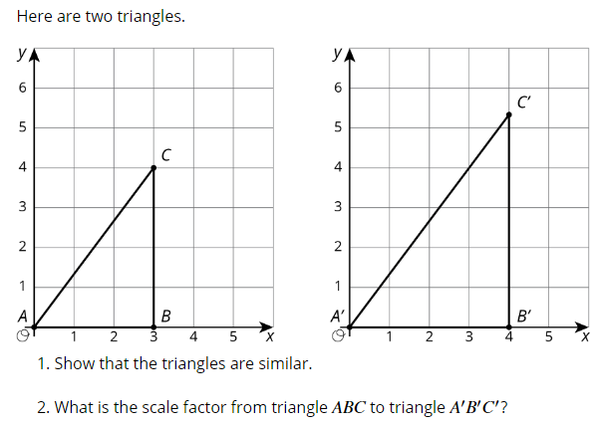

9.

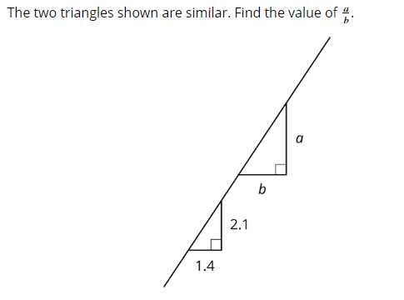

10.

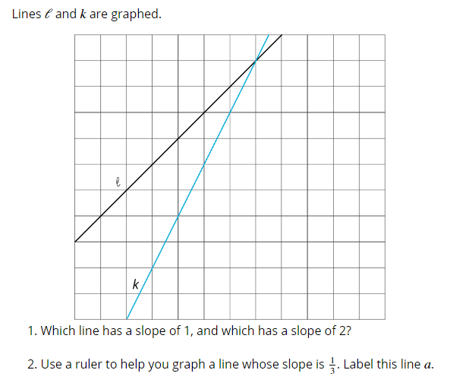

11.

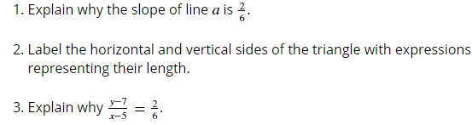

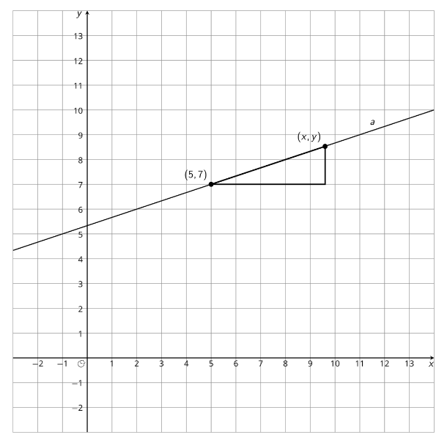

12.

